Falls Free® Wisconsin (FFWI) Social Media Holiday Posts
Find assets at: bit.ly/44hPu7v
*Share Falls Free Wisconsin’s Facebook posts and/or tag us in your posts!

Date | Asset | Suggested Message for Social Media
10/27 | Beware of Falls  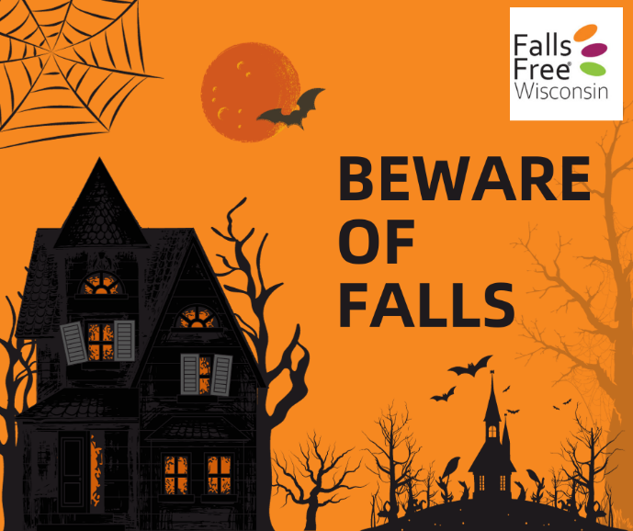 | This Halloween don’t be afraid to treat yourself! Learn how to reduce your risk of a trip and fall with our Home Safety Challenge at bit.ly/3YhPyty #FallsFreeWI
10/31 | Halloween  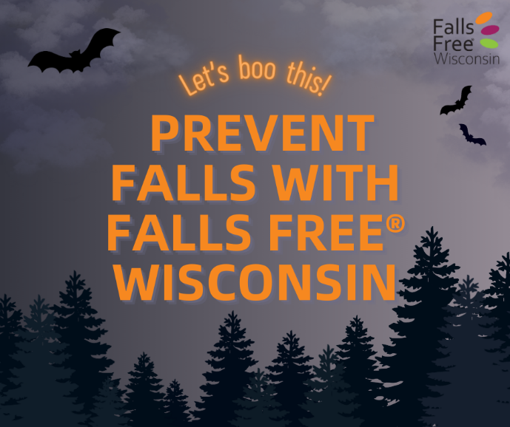 | Falling is scary; preventing falls doesn’t have to be. No tricks, just treats at FallsFreeWI.org #FallsFreeWI
11/6 | Leaves  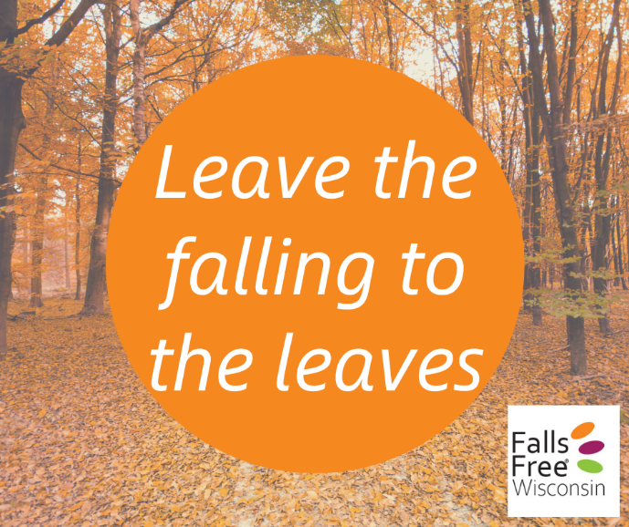 | Fall is beautiful; falling isn’t. Learn how to prevent falls at FallsFreeWI.org #FallsFreeWI
11/15 | Hunting  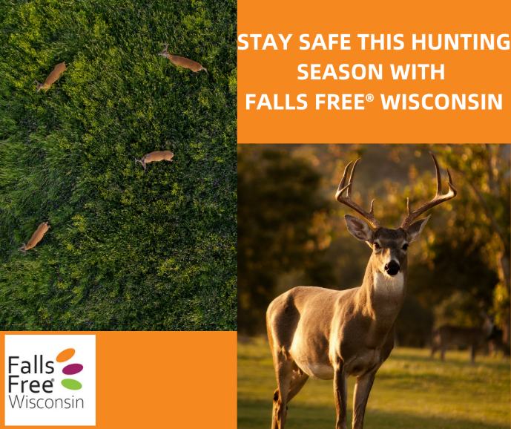 | A pastime for many in Wisconsin, it’s important to use safety gear properly to avoid falls while hunting. Find more tips to stay #FallsFree at FallsFreeWI.org #FallsFreeWI
11/21 | Caregiver  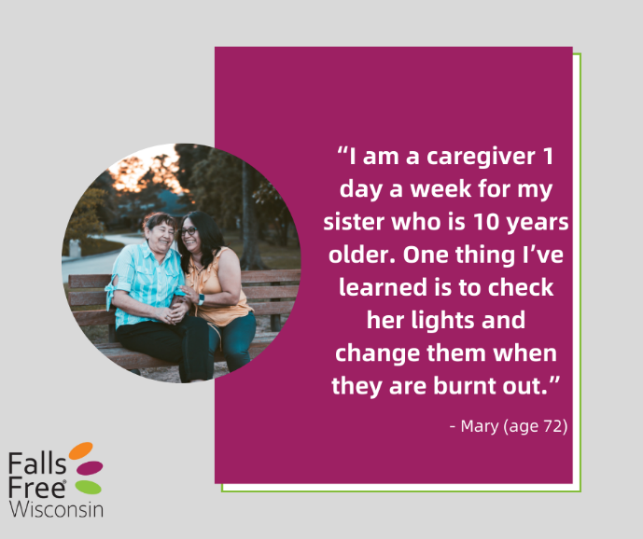 | Taking care of the people in your life can include simple things - like changing burnt out lightbulbs, installing handrails or grab bars, or getting the holiday decorations down from the attic. Learn more ways to help a loved one prevent a fall with our Home Safety Challenge at bit.ly/3YhPyty #FallsFreeWI
11/23 | Turkey  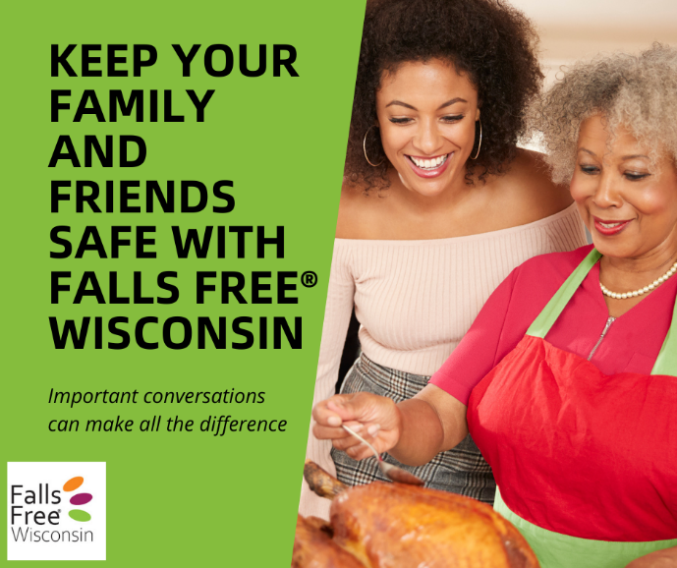 | As you gather with family, friends, neighbors or maybe even strangers this holiday season, start the conversation about falls prevention to help those around you learn what they can do to stay #FallsFree. For conversation topics to share over a piece of pie, go to bit.ly/3PFCnfG #FallsFreeWI
11/24 | Grandparents   | This holiday season, give your family the gift of staying #FallsFree. Take action to prevent falls by learning more about your falls risk at bit.ly/3KnJjeZ #FallsFreeWI
11/30 | Family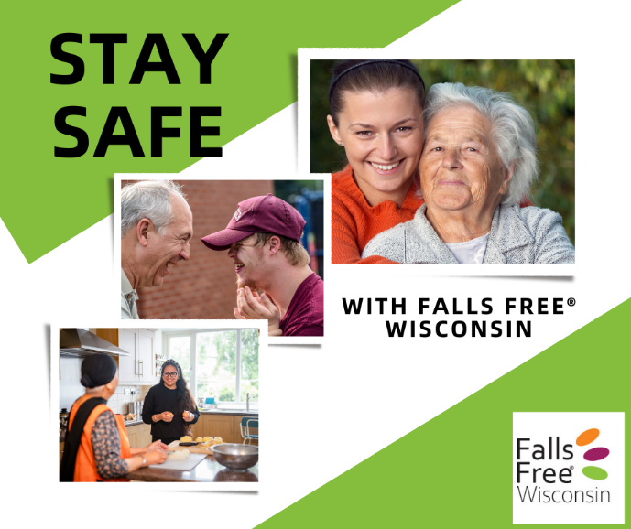 | Keep doing the things you love with the people you love. Visit bit.ly/3QaZ4YJ for tips to prevent falls #FallsFreeWI
12/6 | Winter  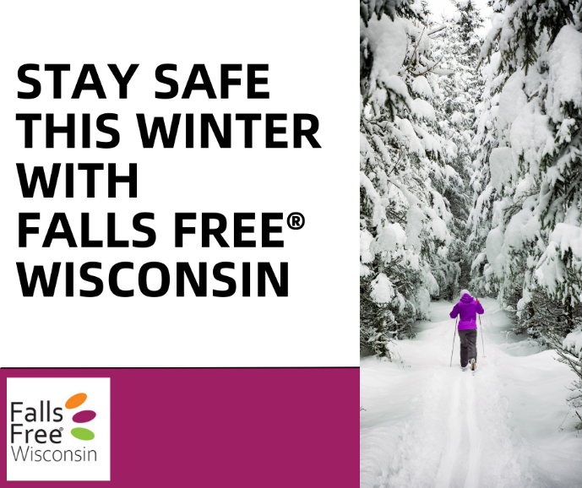 | Good footwear can make all the difference during Wisconsin’s long snow and ice season. Learn the features of safe and unsafe shoes and other safety tips at bit.ly/45bEk93 #FallsFreeWI
12/15 | Holiday Story  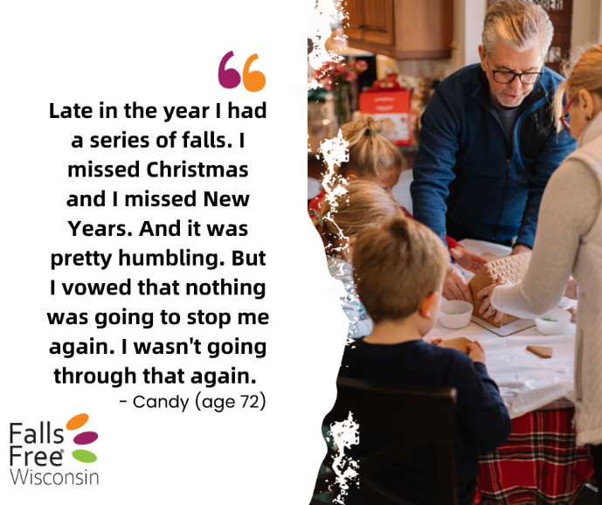 | You’re not alone! Hear from others throughout Wisconsin who have fallen at bit.ly/3rXivvJ and find steps to reduce your risk #FallsFreeWI
12/20 | Cookies  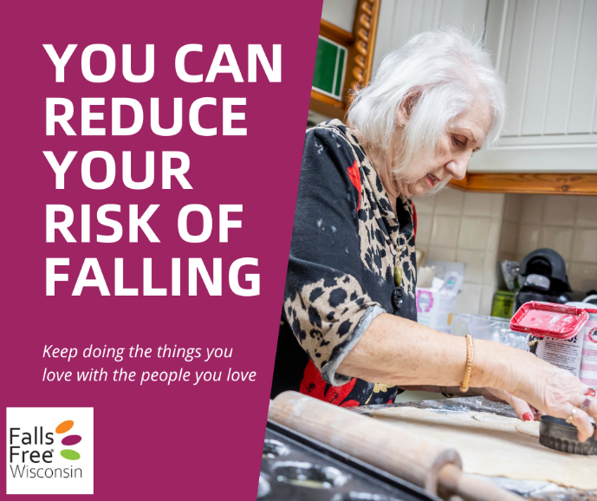 | Keep baking for many years to come. Visit FallsFreeWI.org to learn ways to reduce your risk of falling so you can keep doing the things you love to do #FallsFreeWI
12/23 | Holiday Season  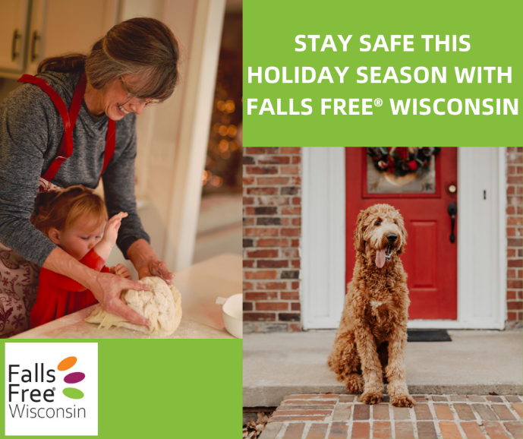 | Is your house filled with toys from your grandkids or pets? Want to help your mom and dad stay safe in their home? Learn how to stay #FallsFree at by taking our Home Safety Challenge at bit.ly/3YhPyty #FallsFreeWI
12/25 | Holiday Bow   | Falls Free® Wisconsin is a one-stop-shop for falls prevention education. With simple tips and tricks you can incorporate into your everyday life, it’s the gift that keeps on giving. Test your knowledge and take the Falls Free Check Up to learn more about your falls risk at bit.ly/3KnJjeZ #FallsFreeWI
12/26 | Team Effort  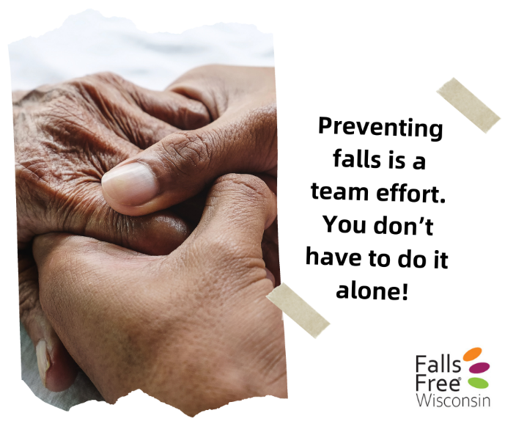 | Your team might include your parents, children, partner, friend, neighbor, physical therapist, healthcare provider, pharmacist, Aging & Disability Resource Center, optometrist, or others – you’re not alone. Have conversations with people you trust so you can stay #FallsFree. Learn how at bit.ly/3PFCnfG #FallsFreeWI
12/29 | Ice fishing  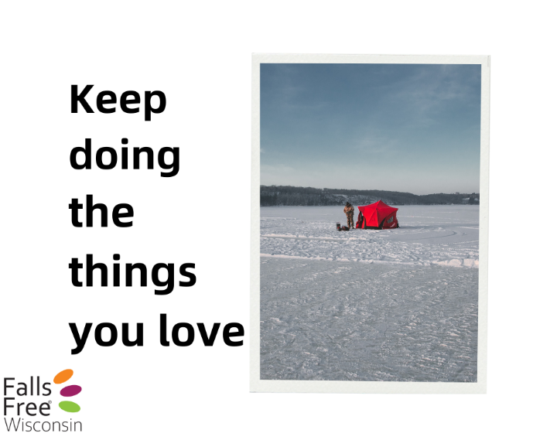 | By making small changes, you can reduce your risk of falling and increase your confidence in staying #FallsFree. Visit FallsFreeWI.org to learn more #FallsFreeWI
12/31 | Packers  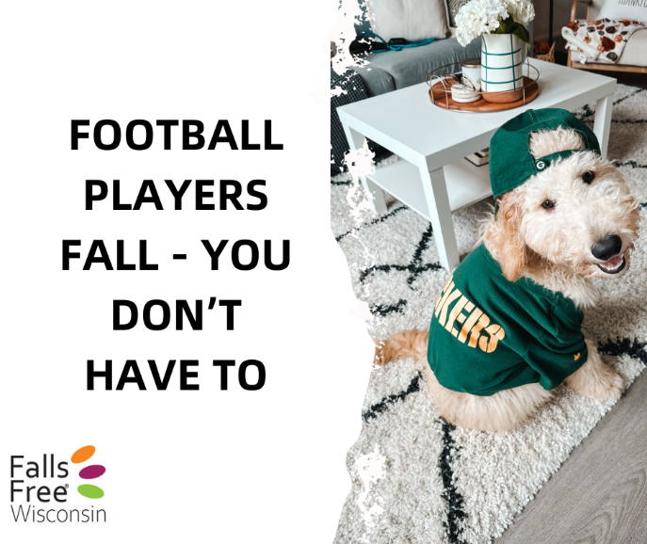 | The professionals knock each other down for a living. Stay steady on your feet by practicing balance and strength exercises from the comfort of your living room during the commercial breaks. Find exercise examples (and even a log to track your exercises) at bit.ly/47cmQn3 #FallsFreeWI  [There is a Packers game today @ 7:20PM]
1/1 | Stay Active  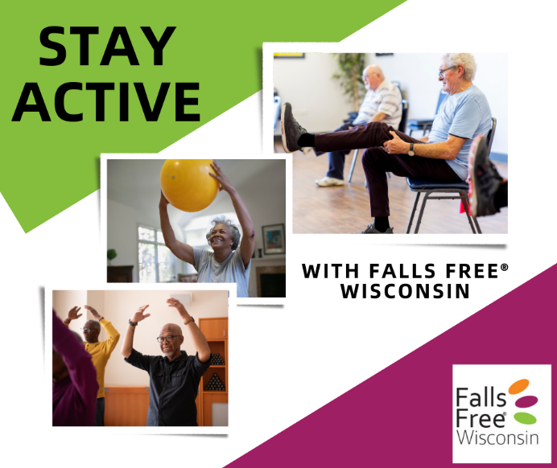 | Practicing balance and strength exercises can help prevent falls. Find some simple exercises you can do to stay #FallsFree and information on how to join an exercise or falls prevention program near you at bit.ly/47cmQn3 #FallsFreeWI

