Falls Free® Wisconsin (FFWI) Social Media Winter Posts
Right click and “Save as Picture” to download images.
*Share Falls Free Wisconsin’s Facebook posts and/or tag us in your posts!
Asset | Suggested Message for Social Media
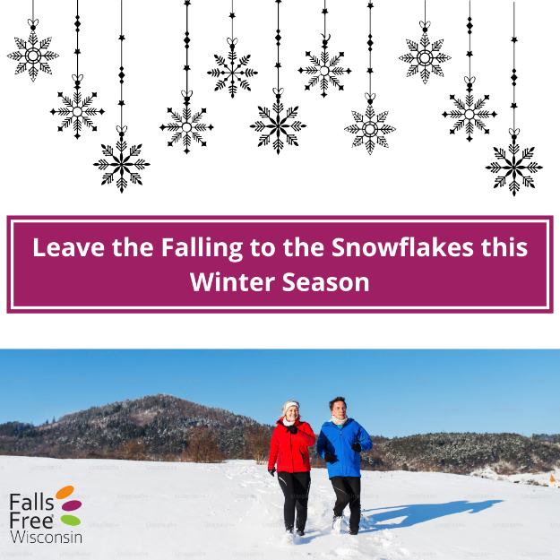 | Falling snowflakes are beautiful; falling isn’t. Learn how you can prevent falls this winter at FallsFreeWI.org #FallsFreeWI
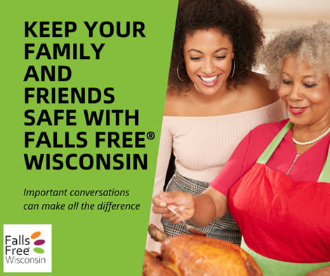 | As you gather with family, friends, neighbors or maybe even strangers this holiday season, start the conversation about falls prevention to help those around you learn what they can do to stay #FallsFree. For conversation topics to share over a piece of pie, go to https://fallsfreewi.org/prevent-falls/conversations/ #FallsFreeWI
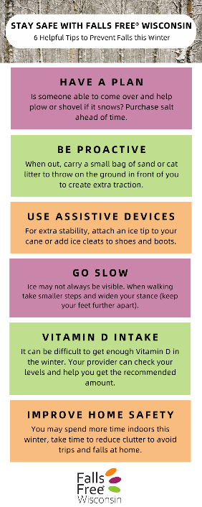 | Here are 6 helpful tips so you can stay #FallsFree this season. Learn more at https://fallsfreewi.org/prepare-to-prevent-falls-this-winter/ #FallsFreeWI
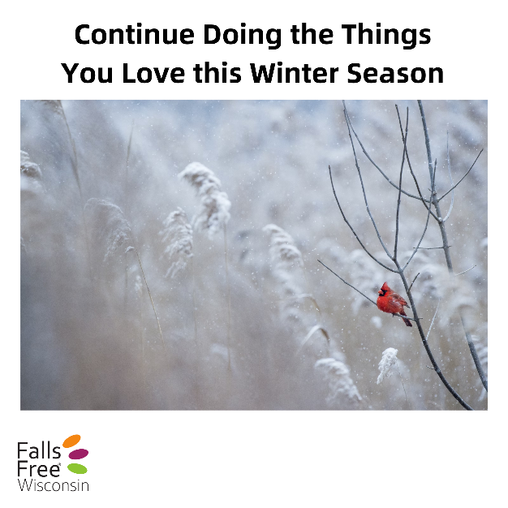 | Learn how you can stay safe and prevent trips and falls at FallsFreeWI.org #FallsFreeWI
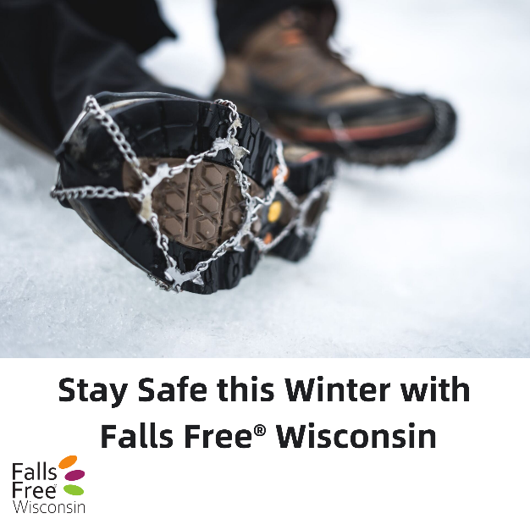 | Snow and ice are here! Learn the features of safe and unsafe shoes and other safety tips at https://fallsfreewi.org/prevent-falls/footwear/ #FallsFreeWI
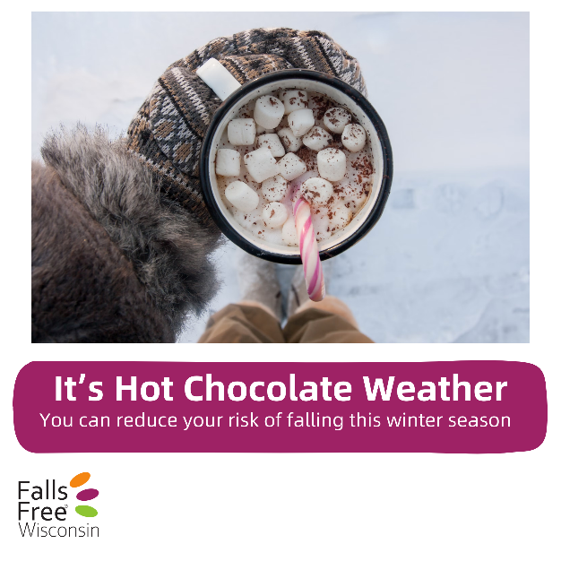 | Stay warm this winter and learn how you can reduce your risk of falling at FallsFreeWI.org #FallsFreeWI
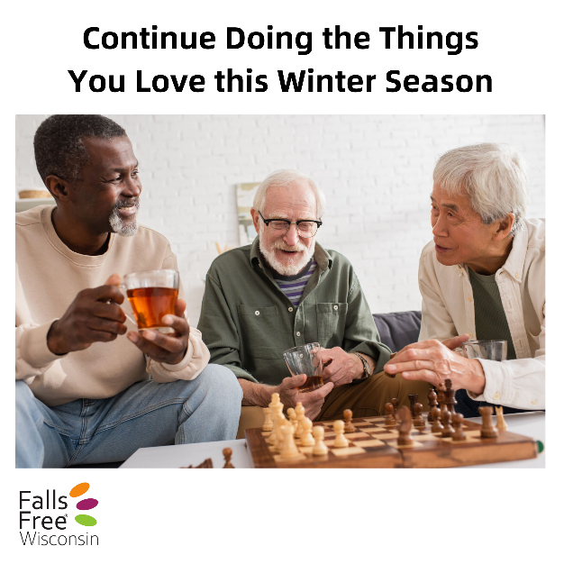 | Don’t stop doing the things you love. Learn how you can prevent falls and trips at FallsFreeWI.org #FallsFreeWI
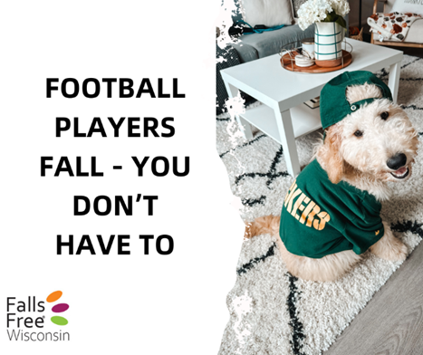 | Let the professionals knock each other down for a living. Stay steady on your feet by practicing balance and strength exercises from the comfort of your living room during the commercial breaks. Find some simple exercises to start with at https://fallsfreewi.org/prevent-falls/balance-strength/ #FallsFreeWI
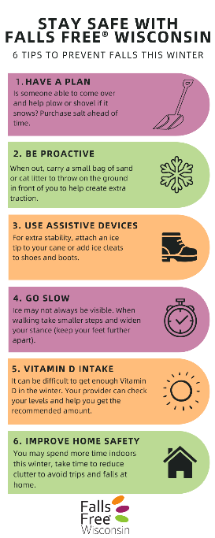 | Remember these 6 helpful tips to have a safe and healthy winter while preventing trips and slips. For more information on winter safety go to https://fallsfreewi.org/prepare-to-prevent-falls-this-winter/ #FallsFreeWI
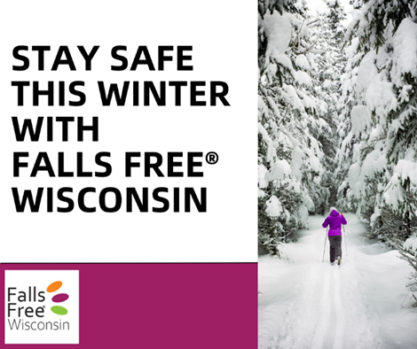 | Good footwear can make all the difference during Wisconsin’s long snow and ice season. Learn the features of safe and unsafe shoes and other safety tips at https://fallsfreewi.org/prevent-falls/footwear/ #FallsFreeWI
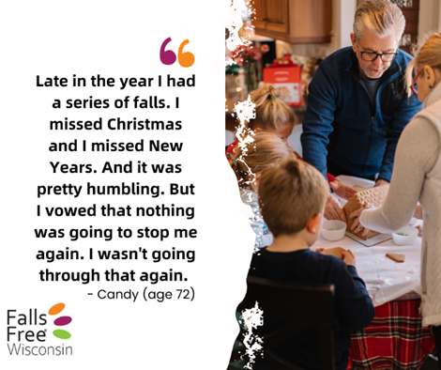 | You’re not alone! Hear from others throughout Wisconsin who have fallen at https://fallsfreewi.org/prevent-falls/falls-stories/ and find steps to reduce your risk #FallsFreeWI
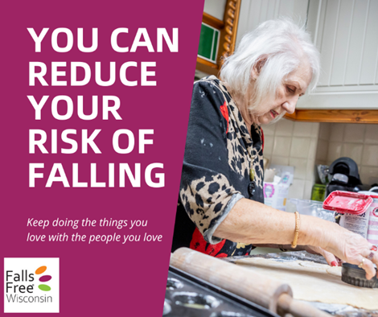 | Keep baking for many years to come. Visit FallsFreeWI.org to learn ways to reduce your risk of falling so you can keep doing the things you love to do #FallsFreeWI
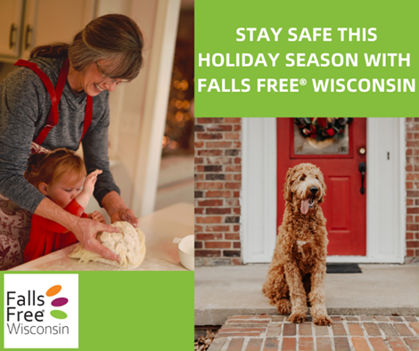 | Is your house filled with toys from your grandkids or pets? Want to help your parents stay safe in their home? Learn how to stay #FallsFree at by taking our Home Safety Challenge at https://fallsfreewi.org/prevent-falls/surround/interactive-home-walk-through/ #FallsFreeWI
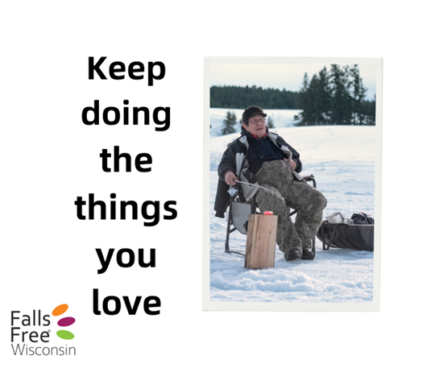 | By making small changes, you can reduce your risk of falling and increase your confidence in staying #FallsFree. Visit FallsFreeWI.org to learn more #FallsFreeWI
 | Falls Free® Wisconsin is a one-stop-shop for falls prevention education. With simple tips and tricks you can incorporate into your everyday life, it’s the gift that keeps on giving. Test your knowledge and take the Falls Free Check Up to learn more about your falls risk at https://fallsfreewi.org/prevent-falls/test-your-knowledge/ #FallsFreeWI

