Date | Asset | Suggested Message for Social Media
5/1/2024 |  | May is National Physical Fitness and Sports Month. Physical activity is one of the most important things you can do for your health! Visit FallsFreeWI.org and learn ways that you can stay active to prevent falls! #FallsFreeWI
5/6/2024 | 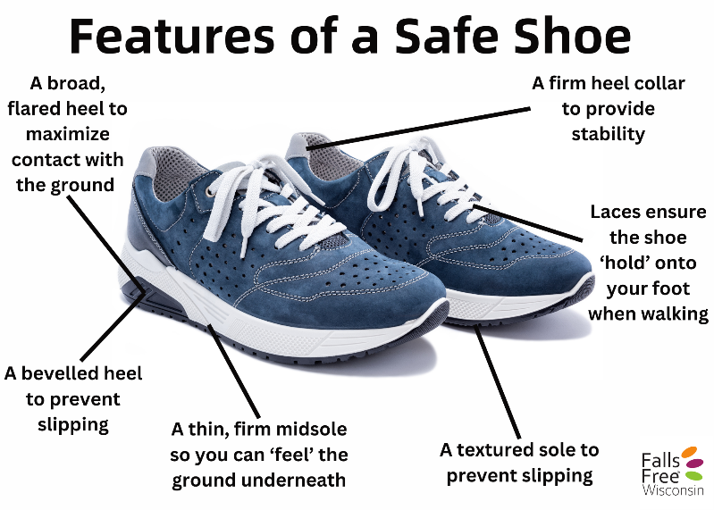 | It is important to wear safe footwear while being physically active! Visit bit.ly/3S6XqIv to learn more about the features of a safe shoe! #FallsFreeWI
5/8/2024 |  | Physical activity is extremely important to help you continue to be able to do your daily activities. Visit bit.ly/48iK1mU to learn about the recommended physical activity guidelines for older adults. #FallsFreeWI
5/14/2024 | 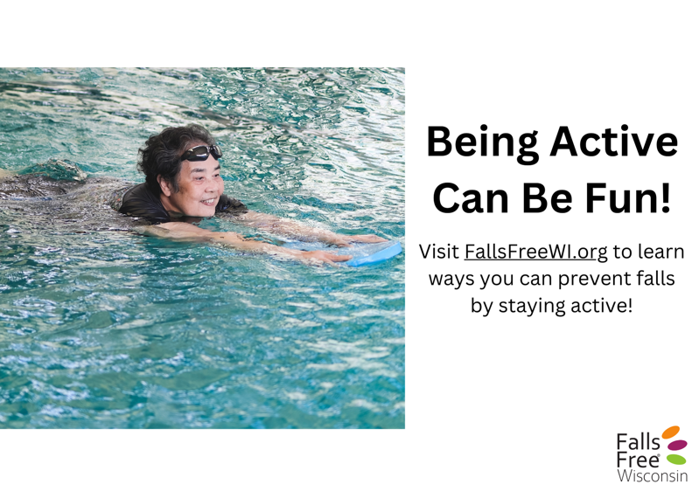 | Swimming, joining a strength or balance class, or checking out your local pickleball or bicycle club, are just some ways you can stay physically active and prevent falls. Visit bit.ly/48iK1mU to learn more. #FallsFreeWI
5/16/2024 | 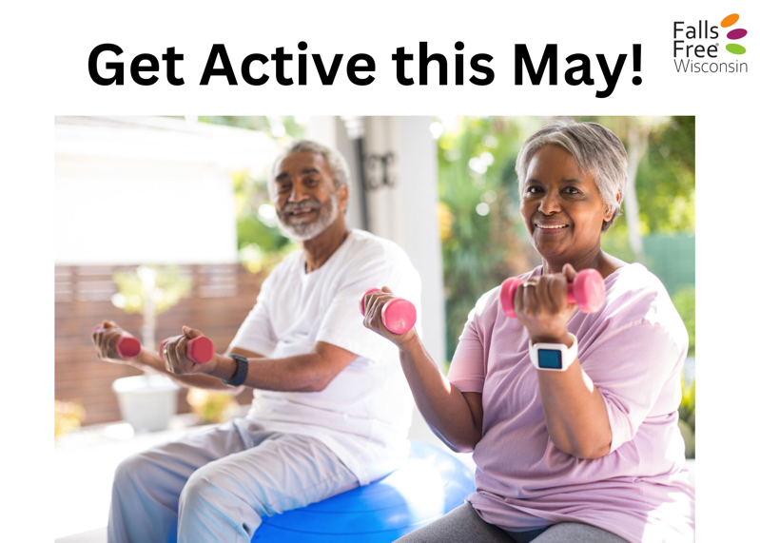 | It’s National Physical fitness and Sports Month – consider joining an exercise class! It is a great way to stay accountable, meet new people, and have fun while improving your balance, strength, and physical fitness. Find more falls prevention tips at FallsFreeWI.org. #FallsFreeWI
5/20/2024 | 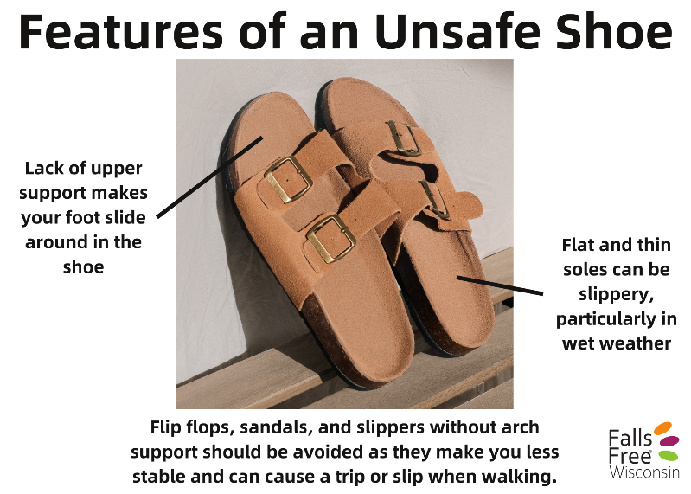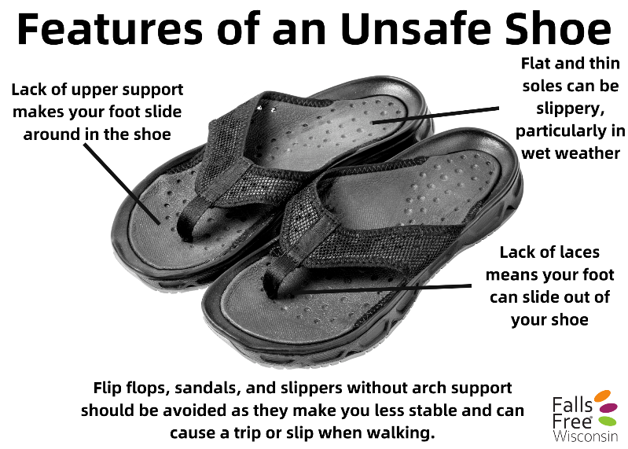 | Spring is here! It is important to wear safe footwear while getting outside and enjoying the weather. Learn more about safe footwear and preventing falls at bit.ly/3S6XqIv #FallsFreeWI
5/22/2024 | 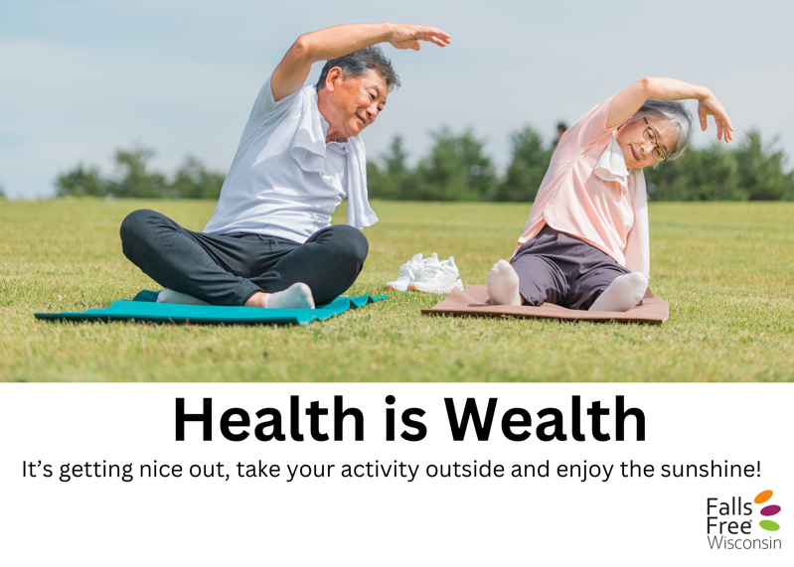 | Improving your balance and increasing strength can reduce your risk of falls – and can be done at all ages! Learn some simple balance and strength exercises at bit.ly/48iK1mU #FallsFreeWI
5/25/2024 | 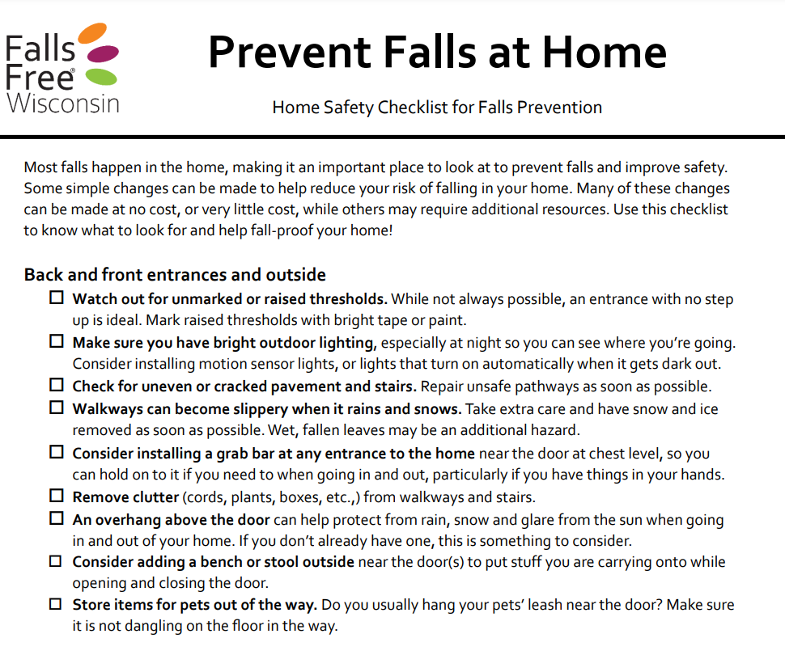 | It’s that time of the year for spring cleaning! Visit bit.ly/48pxj5N  to download and print a home safety checklist to help guide you through your cleaning and keep your home safe this spring!  You can also visit bit.ly/3wsLpGn  and take the Home Safety Challenge to learn more about home hazards and safety tips so that you can prevent falls! #FallsFreeWI
5/29/2024 |  | There are many ways you can stay physically active – not just in May! Grab a buddy and do something you love and help each other stay socially connected while being physically active year-round! Visit FallsFreeWI.org for more ways to prevent falls. #FallsFreeWI

