Date | Asset | Suggested Message for Social Media
9/1 | 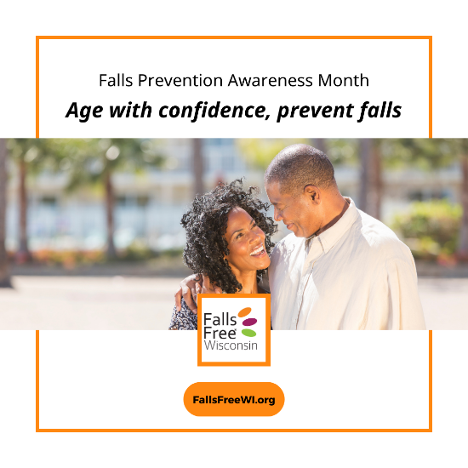 | September is Falls Prevention Awareness Month. There are many things you can do, at any age, to prevent falls and age with confidence. Visit FallsFreeWI.org to learn more and help you get started. #FallsFreeWI
9/3 | 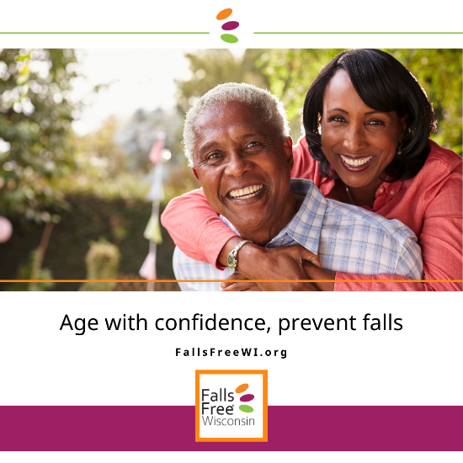 | Having trouble starting the conversation about falls prevention with your healthcare provider or loved ones? Check out the resources at FallsFreeWI.org/prevent-falls/conversations for some helpful tips. #FallsFreeWI
9/5 | 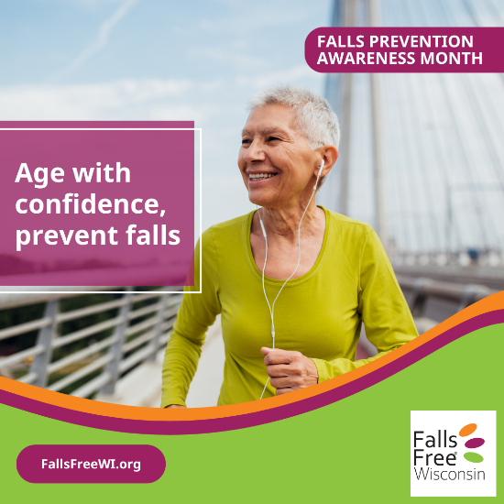 | Falls may be common, but they don’t have to be a normal part of aging. This #FallsPreventionAwarenessMonth, learn what your risk of falling is and find out what you can do to prevent falls – at any age! Learn more at FallsFreeWI.org/prevent-falls/test-your-knowledge. #FallsFreeWI
9/7 | 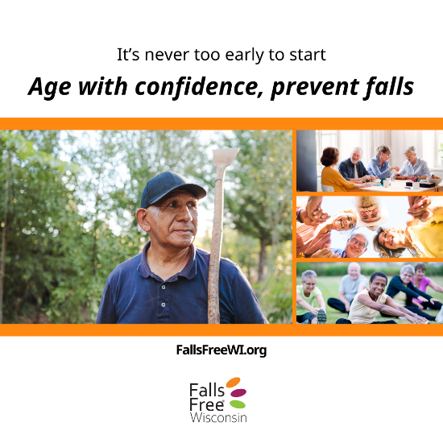 | September means many things – back to school, football games, sweater weather, and falling leaves. Visit FallsFreeWI.org/prevent-falls/assistive-devices to find information about tools like walking sticks to help you stay safe while walking or hiking – and make sure the falling leaves are the only thing on the ground this season. #FallsFreeWI
9/9 | 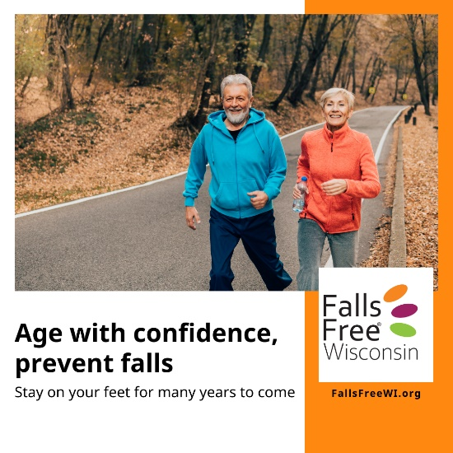 | We spend a lot of time sitting down, which can limit your strength and balance and increase your risk of falling. Go to FallsFreeWI.org/prevent-falls/balance-strength to learn some simple balance and strength exercises you can do from the comfort of your living room – and ways to get more active in your community. #FallsFreeWI
9/13 |  | Falls prevention starts from the ground up – when was the last time you replaced your old, worn-out shoes or slippers? From walking around the house to exercising, what’s on your feet can make all the difference. Visit FallsFreeWI.org/prevent-falls/footwear to learn about the features of a safe shoe. #FallsFreeWI
9/16 |  | Feel like a champion at home. Take Falls Free® Wisconsin’s Home Safety Challenge to identify home hazards and get tips for reducing your risk. Go to FallsFreeWI.org/prevent-falls/surround/interactive-home-walk-through to get started. Be sure to share what you’ve learned with others! #FallsFreeWI
9/19 | 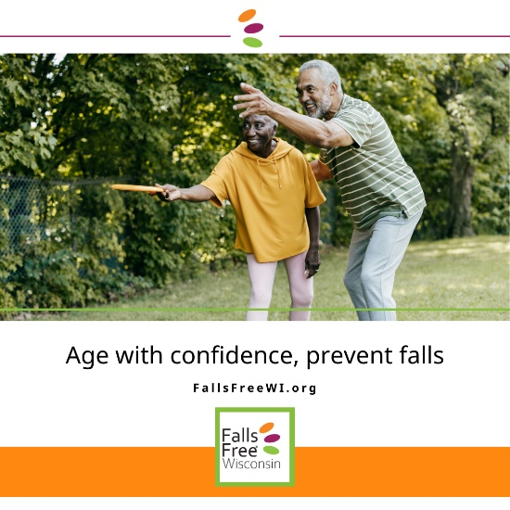 | Medications, including prescriptions, over-the-counter medicines, and herbal supplements can increase your risk of falling. Visit FallsFreeWI.org/prevent-falls/medications to learn how to manage your medications safely. #FallsFreeWI.org
9/22  *National Falls Prevention Awareness Day! |  | Keep your eye on the ball – learn how your sight can change as you get older and take steps to adapt to vision changes to prevent falls. Visit FallsFreeWI.org/prevent-falls/sight to learn more. #FallsFreeWI
9/25 |  | Our ears and hearing can change with time. Learn what to look out for and be sure you’re able to hear your teammate from across the court for many years to come. Visit FallsFreeWI.org/prevent-falls/sound for more information. #FallsFreeWI
9/28 |  | Most falls happen at home. While our surroundings might not change much over the years, we do! There are many things you can do to make your home safer – at any age. Go to FallsFreeWI.org/prevent-falls/surround to spot the hazards and learn what to look for. #FallsFreeWI
9/30 |  | As we close the chapter on Falls Prevention Awareness month, we encourage you to continue to read the book and learn more about what you can do to prevent falls – at any age. Falls Free® Wisconsin can help! Visit FallsFreeWI.org today. #FallsFreeWI

