Date | Asset | Suggested Message for Social Media
8/21 | 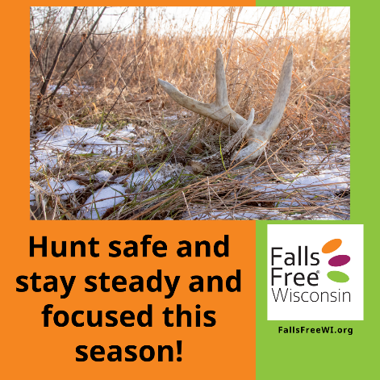 | It’s almost that time of year - fall in Wisconsin is a beautiful time to be outside, go for a hike, or sit in a deer or tree stand. Learn how you can prevent falls this hunting season and beyond at FallsFreeWI.org/stay-falls-free-this-hunting-season.
8/27 | 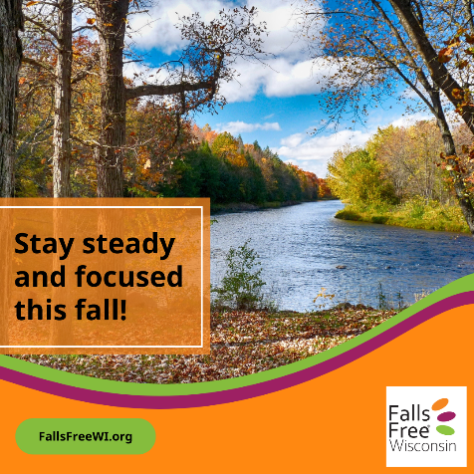 | Stay on your feet – learn how to prevent falls at FallsFreeWI.org.
8/29 | 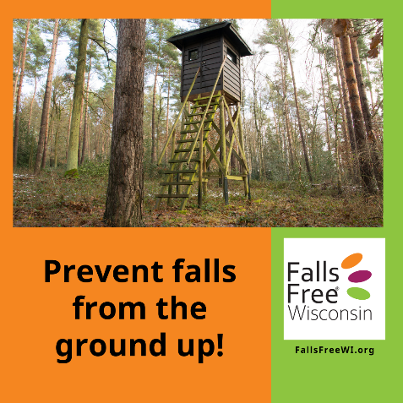 | Falls are common during hunting season. It’s important to think about safety in hunting stands. Installing handrails on both sides of the steps up to your stand is just one way you can reduce your risk of a fall. Visit FallsFreeWI.org/stay-falls-free-this-hunting-season to learn more!
9/4 | 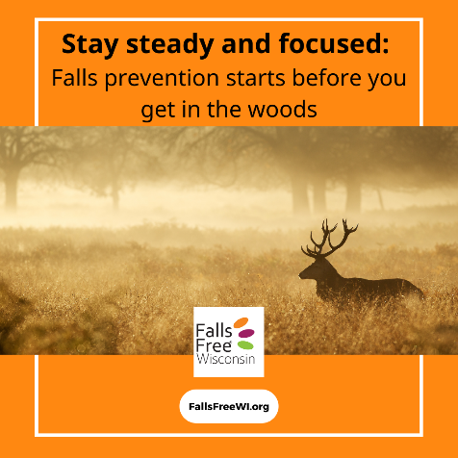 | A good hunter prevents falls during all seasons. Learn ways that you can reduce your falls risk and stay safe at FallsFreeWI.org.
9/7 | 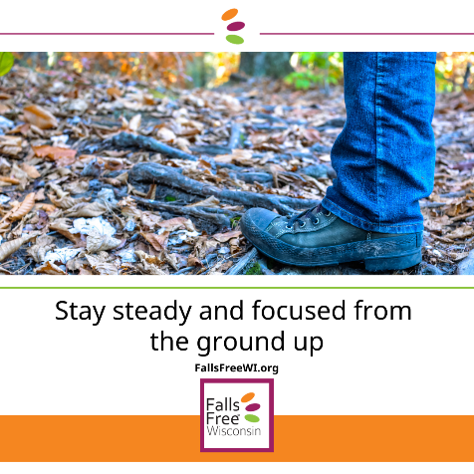 | Falls prevention starts from the ground up – whether you’re walking around your house or out in the woods. Learn the features of safe shoes at FallsFreeWI.org/footwear
9/10 | 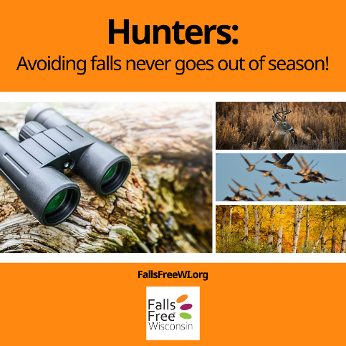 | You can prevent falls year-round! Learn how at FallsFreeWI.org.
9/14 | 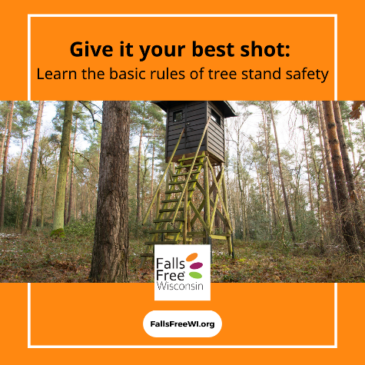 | Learn the basic rules of tree stand safety from Lieutenant Michael Weber, Warden in charge of the Hunter Education Program at the @Wisconsin Department of Natural Resources at FallsFreeWI.org/stay-falls-free-this-hunting-season.
9/18 | 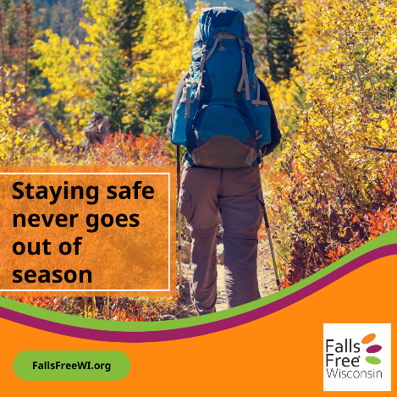 | Prevent falls no matter the season – how can assistive devices like walking sticks, smart speakers, medical alert devices and more help you prevent falls in and out of the woods? Visit FallsFreeWI.org/assistive-devices to learn how.
9/23 | 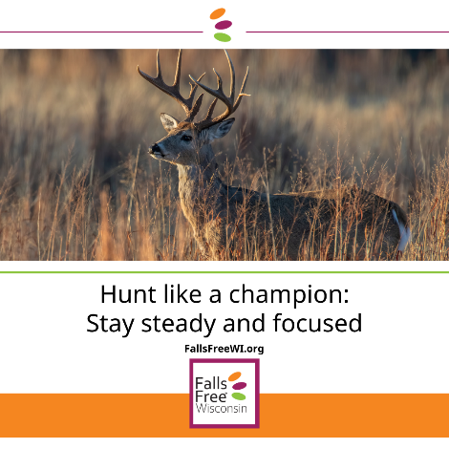 | Don’t just be a hunting champion, but also a falls prevention champion! You can learn more ways to have a safe hunting season and stay steady and focused when you visit FallsFreeWI.org.

