Asset | Suggested Message for Social Media
https://drive.google.com/file/d/1NwRYCtb0NsIniMFrS6ldQ1tlUZv2__aG/view?usp=drive_link  (download 30-second video PSA and upload to Facebook post – please do not share link!) | Fall for your sweetheart, not over your rug. This month, take care of yourself and your loved ones by staying safe and aging independently – visit FallsFreeWI.org to learn how. #FallsFreeWI
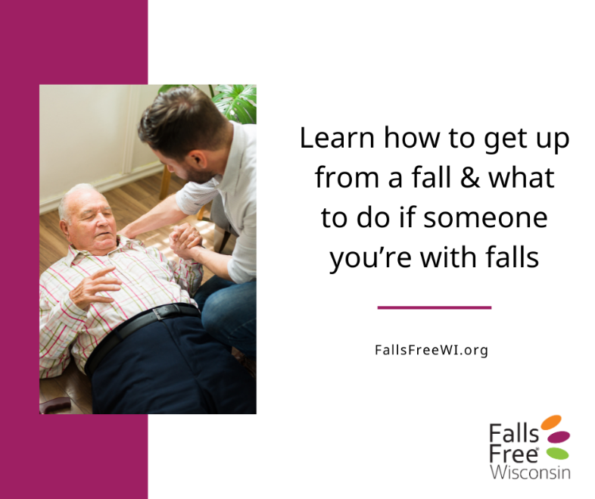 | What should you do if you fall? Watch Physical Therapist Melissa Lydecker show how to get up from a fall and find other tips – like what to do if you’re with someone who fell – at https://fallsfreewi.org/prevent-falls/what-if-i-fall/ #FallsFreeWI
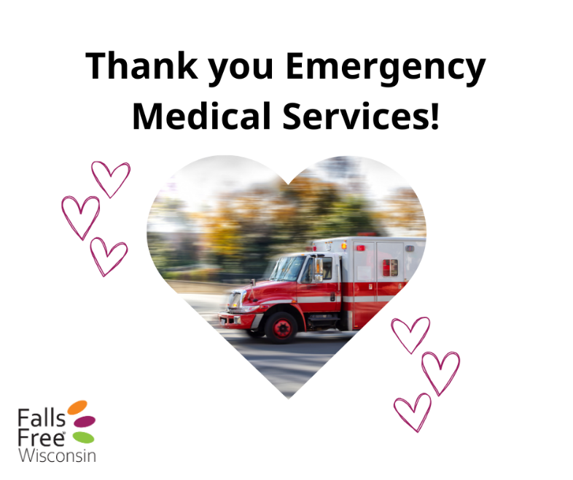 | Did you know? If you fall and simply need help getting up, Emergency Medical Services (EMS) providers are able to help! Hear from one Wisconsin EMS provider on what they do to help someone after they fall [link to article: https://fallsfreewi.org/i-fell-now-what/] #FallsFreeWI
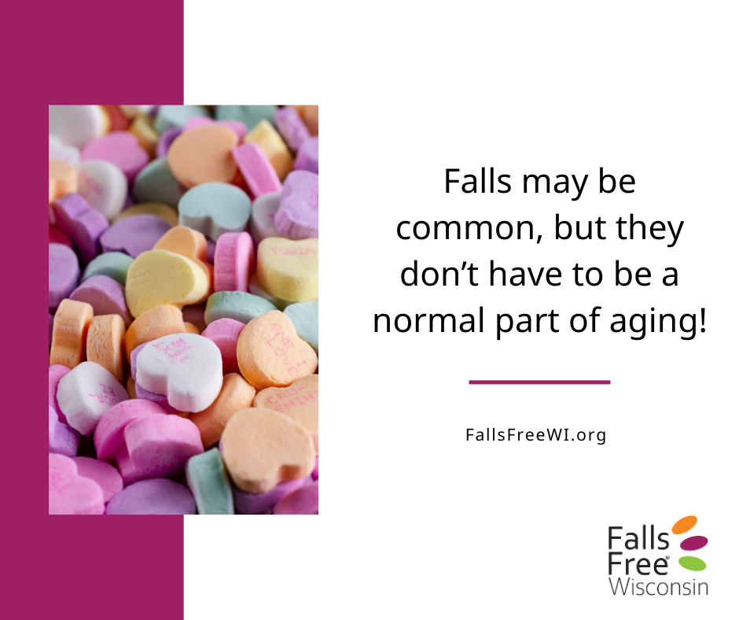 | Not all conversations fit on conversation hearts. Find tips for starting the conversation about preventing falls as we age at https://fallsfreewi.org/prevent-falls/conversations/ #FallsFreeWI
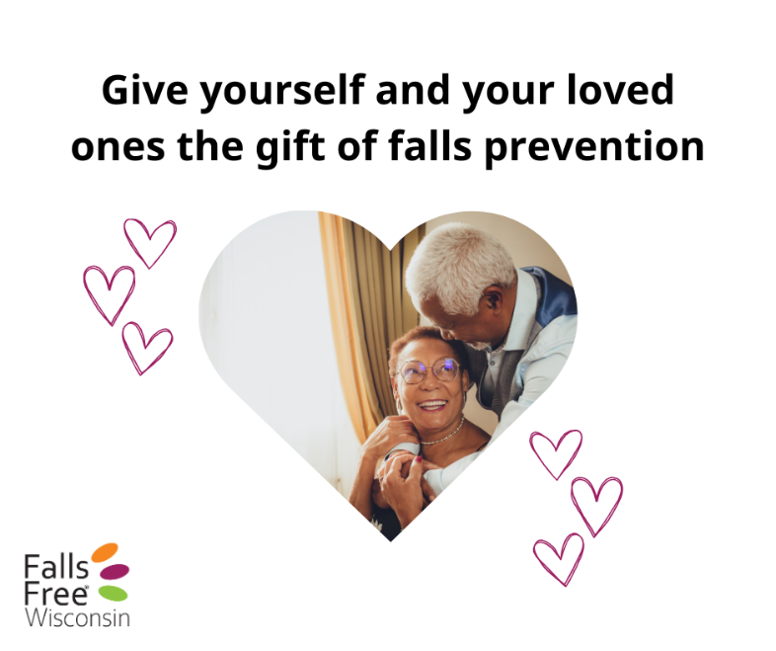 | Chocolate is sweet, but staying #FallsFree is even sweeter. Visit FallsFreeWI.org today and take steps to reduce your risk of falling – for yourself AND for them.
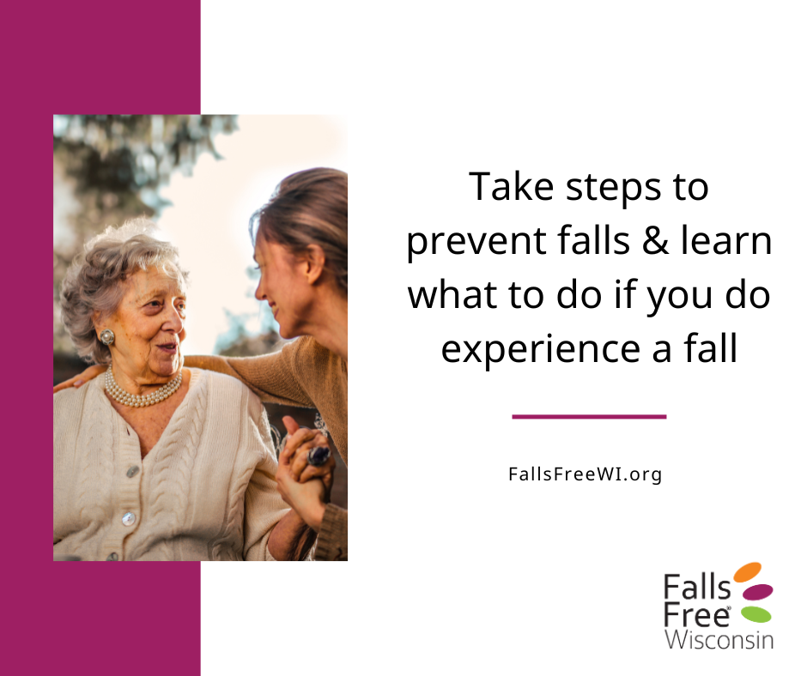 | Visit FallsFreeWI.org and find balance and strength exercises, home safety tips, and other tools to prevent falls – including what to do if you or someone you know does have a fall #FallsFreeWI
 | Our 4-legged friends bring so much joy but can also cause trips and falls! Find tips for getting up from a fall, and how to prevent them, at FallsFreeWI.org #FallsFreeWI
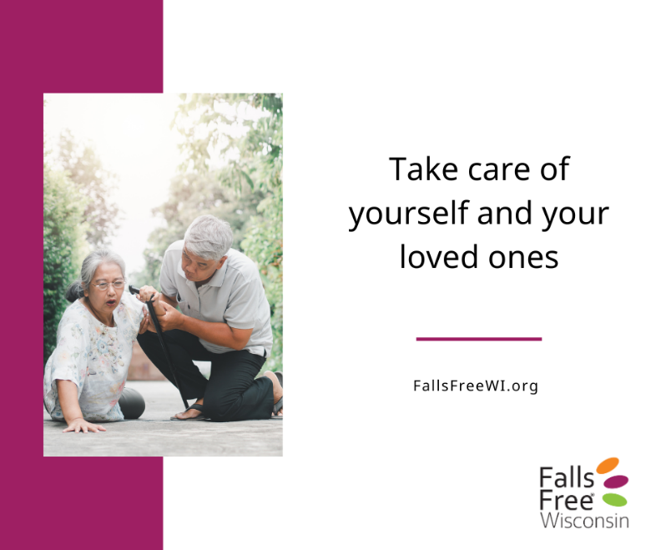 | What should you do if someone around you falls? What if they’re injured? Learn what steps to take at https://fallsfreewi.org/prevent-falls/what-if-i-fall/ and find tips to help prevent falls #FallsFreeWI
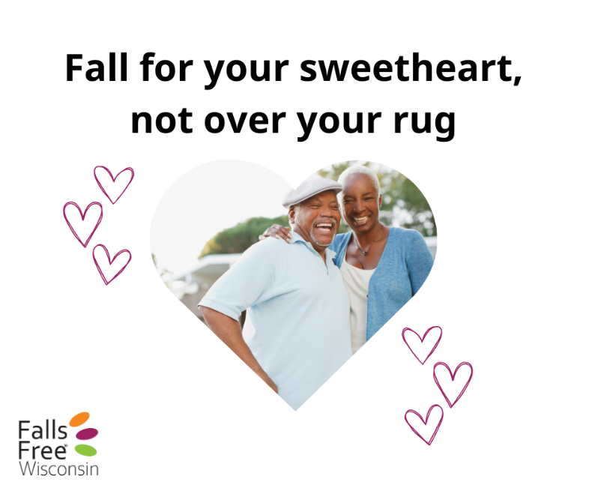 | Falls may be common, but they don’t have to be a normal part of aging! Keep falling for your sweetheart, but learn how to prevent falling to the floor at FallsFreeWI.org #FallsFreeWI

