Asset | Suggested Message for Social Media
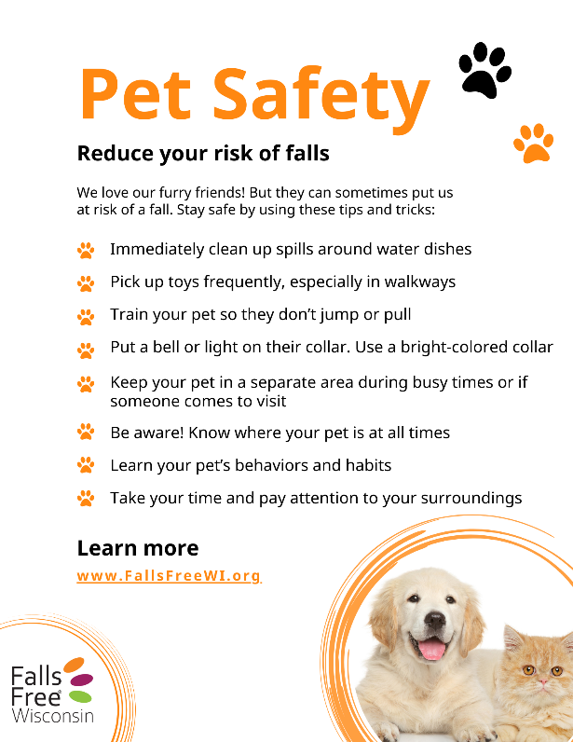 | Our four-legged friends are wonderful companions who help keep us active, but they can also increase our risk of falls. Learn how to stay safe and age independently by visiting FallsFreeWI.org. #FallsFreeWI
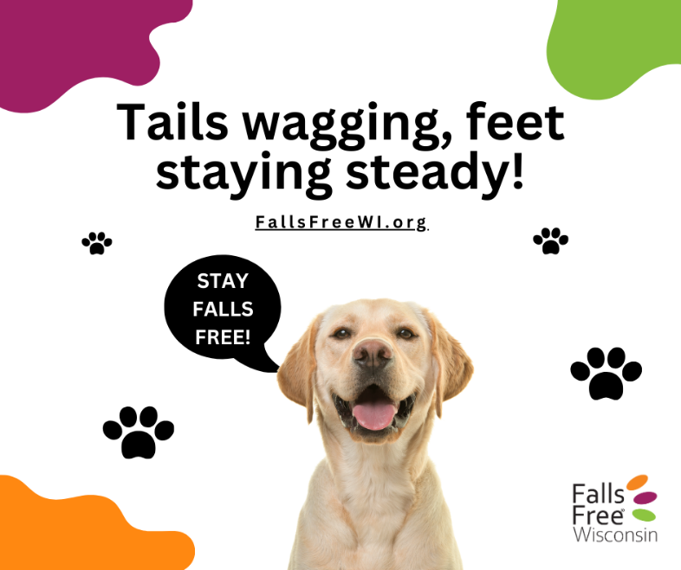 | Our furry friends keep us moving, but let’s keep it safe! Stay steady, watch your step, and prevent falls while enjoying time with your pet. Learn more at FallsFreeWI.org #SafeSteps #FallsFreeWI
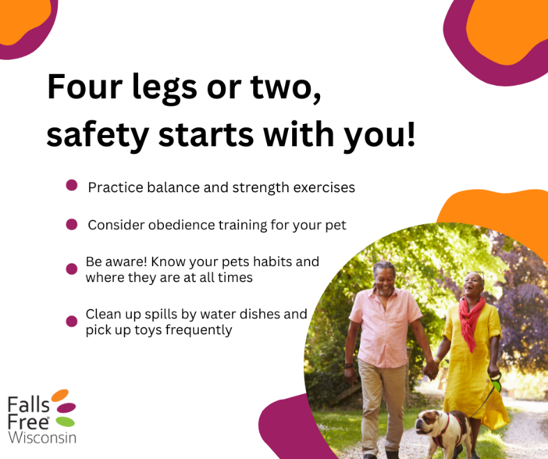 | As we age, it’s important to take steady steps to prevent trips and falls as we age. Visit FallsFreeWI.org for more tips to #StaySteady. #FallsFreeWI
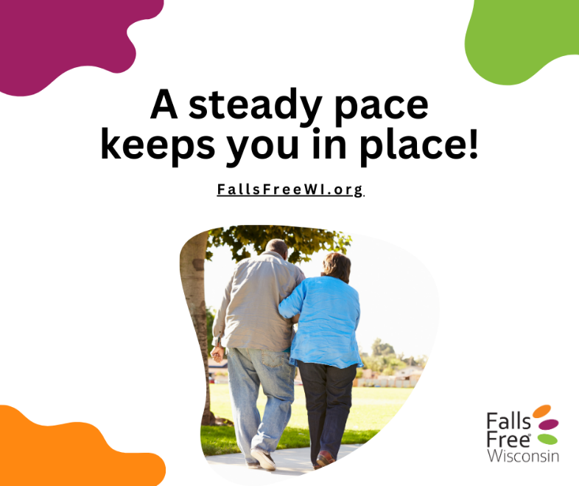 | Preventing falls and aging independently starts with you! Simple habits like mindful movement and staying active can keep you safe and steady. Find out more at FallsFreeWI.org. #FallsFreeWI
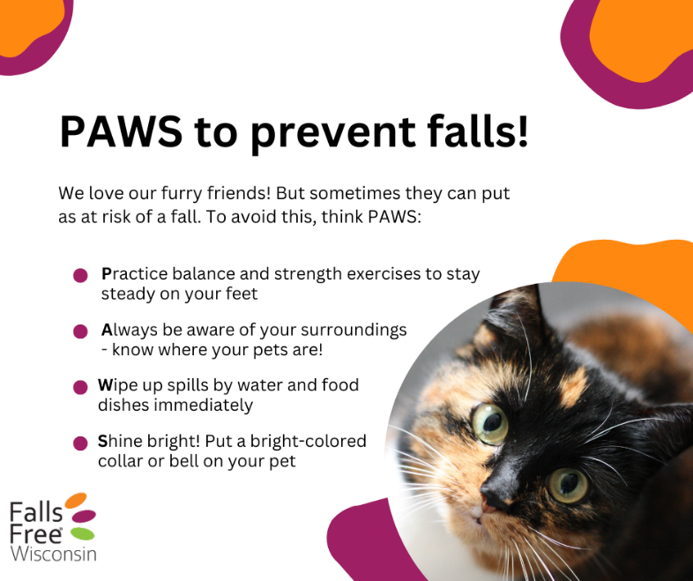 | Love your pet, love your balance! Be mindful of leashes, toys, and quick movements to stay on your feet and prevent falls. FallsFreeWI.org is here to help – find simple balance and strength exercises and more to #StaySteady. #FallsFreeWI
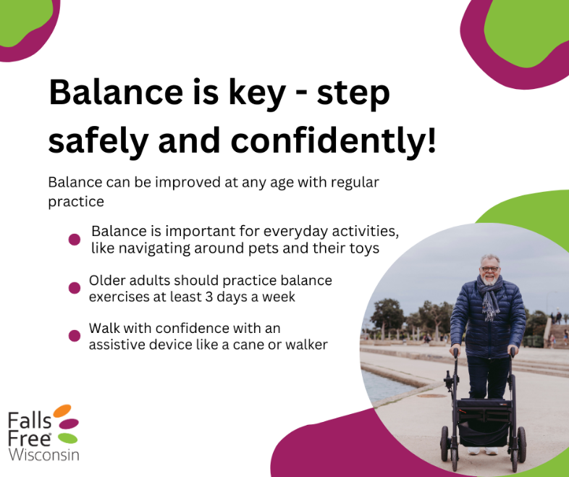 | Good balance is the key to confidence! Stay active, wear safe shoes, and keep your home free of hazards. Learn more at FallsFreeWI.org. #FallsFreeWI
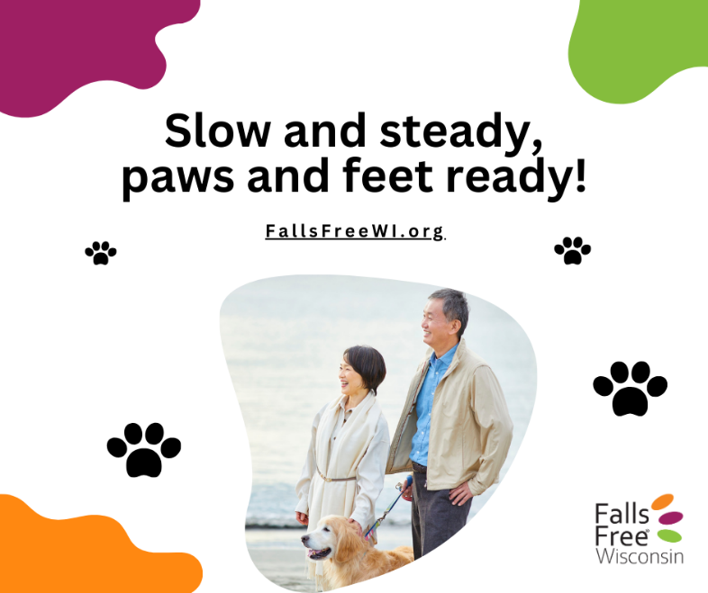 | Pets bring us joy and movement – just be sure to walk with care! A steady pace keeps both you and your furry friend safe. Find simple balance and strength exercises to help you #StaySteady at FallsFreeWI.org/balance-strength. #FallsFreeWI
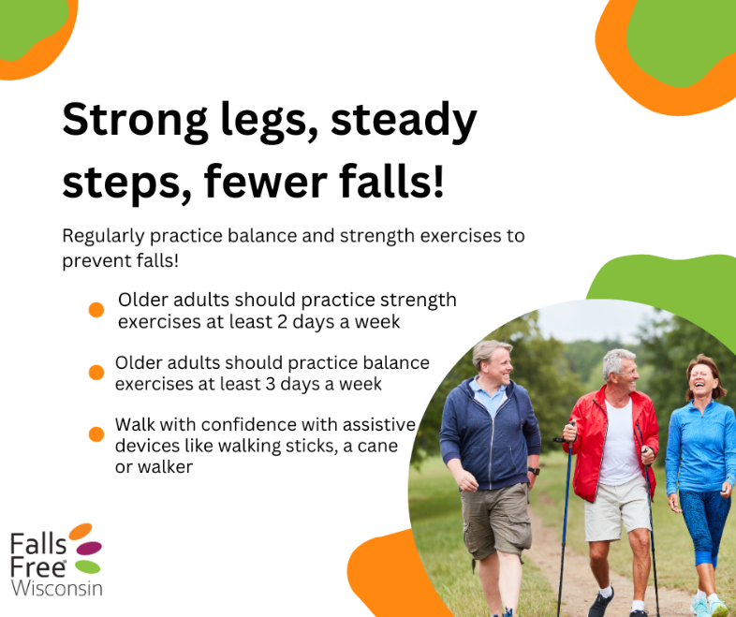 | One strong step at a time! Strength and balance exercises can keep you on your feet and reduce your falls risk. Visit FallsFreeWI.org for more tips. #FallsFreeWI
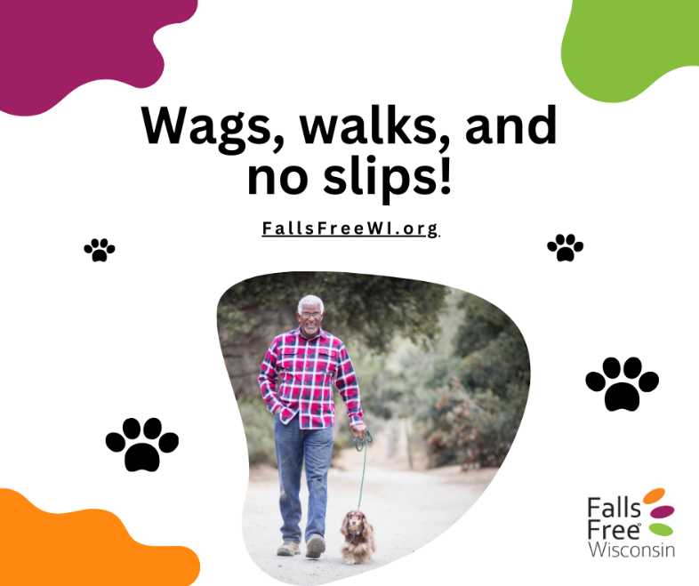 | Stay active with your furry friend and reduce your risk of falls! Visit FallsFreeWI.org to learn about balance and strength exercises, safe footwear, home safety, vision, hearing, and more to avoid slips and trips. #FallsFreeWI
https://drive.google.com/drive/folders/19aii40ssWI-ZrbRLvpJHSEz3X-BqalRq?usp=drive_link  (download 15 or 30-second video PSA and upload to Facebook post – do not share link!) | Fall for a joke, not over your dog. Take care of yourself and your furry friends by staying safe and aging independently – visit FallsFreeWI.org to learn how. #FallsFreeWI

