Date | Asset | Suggested Message for Social Media
9/2 | 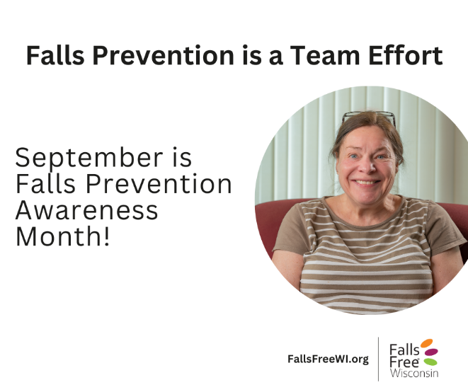 | Let’s work together to make our communities safe for everyone, no matter the age.  ✅ Sidewalks that are easy to use  ✅ Homes that are safe and affordable as we age  ✅ Parks and public places that feel safe  ✅ Buildings and spaces made for all ages  Preventing falls as we age isn’t just one person’s job, it takes all of us.  We’re in this together! Learn how you can help at FallsFreeWI.org. #FallsPreventionAwarenessMonth #FallsPreventionIsATeamEffort #FallsFreeWI
9/4 | 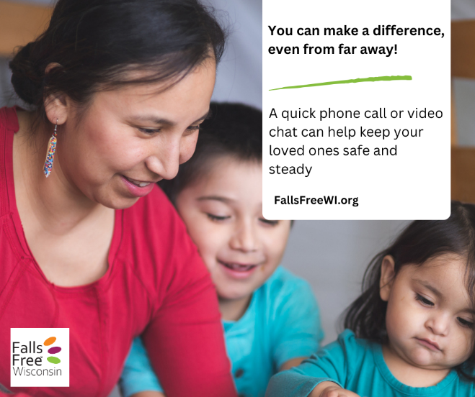 | Preventing falls takes teamwork — and you’re part of the team! 💌 You don’t have to live close by to help someone you care about stay safe from falls.  No matter where you live, you can:  ✔ Check in often  ✔ Help set up or join doctor visits online  ✔ Find local help or services  💡 Want to learn more about preventing falls in Wisconsin? Visit FallsFreeWI.org. #FallsPreventionAwarenessMonth #FallsPreventionIsATeamEffort #FallsFreeWI
9/7 | 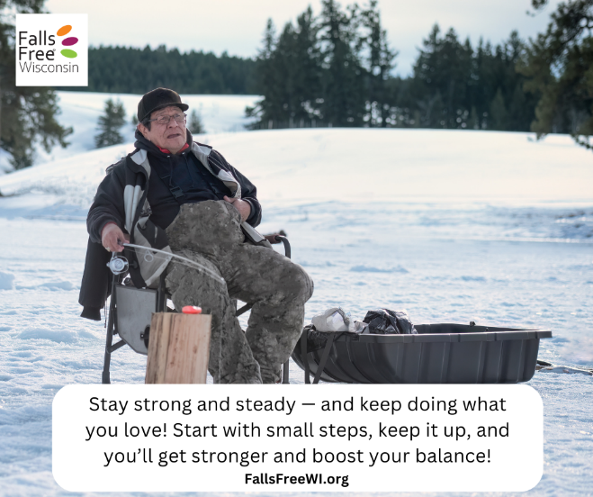 | Staying active is one of the BEST ways to prevent falls!  🏋️‍♀️ Strength and balance exercises keep your legs strong and help you feel more confident on your feet.  Just a few minutes a day can make a big difference. Start today — your future self will thank you!  👟 Ready to stay safe and strong? Find tips, tools, and resources at FallsFreeWI.org.  #FallsPreventionAwarenessMonth #FallsPreventionIsATeamEffort #FallsFreeWI
9/10 | 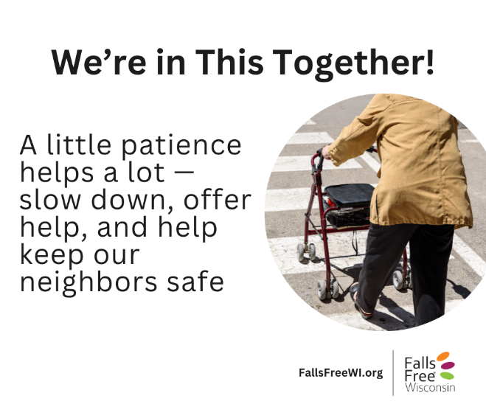 | See someone crossing the road slowly?  ⏳ Slow down, be kind, and offer help if they need it.  Holding a door, waiting a few more seconds, or giving someone space can stop a fall and show respect. Let’s use patience to help keep each other safe.  We’re all in this together! Learn how you can help at FallsFreeWI.org. #FallsPreventionAwarenessMonth #FallsPreventionIsATeamEffort #FallsFreeWI
9/12 | 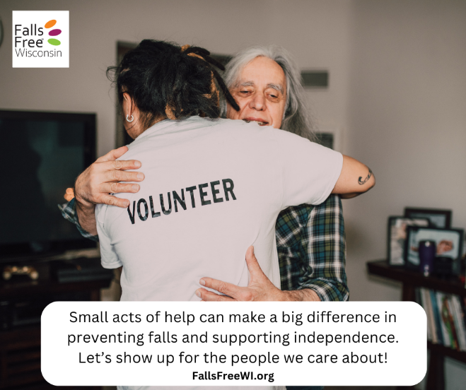 | 🛠 Helping with small tasks can stop big problems. You can offer to:  💡 Change lightbulbs  🧹 Clear walkways  💊 Remind someone to take their medicine  🚗 Go with to appointments  These kind actions help your loved ones stay safe and independent.  We’re all in this together! Learn how you can help at FallsFreeWI.org. #FallsPreventionAwarenessMonth #FallsPreventionIsATeamEffort #FallsFreeWI
9/14 | 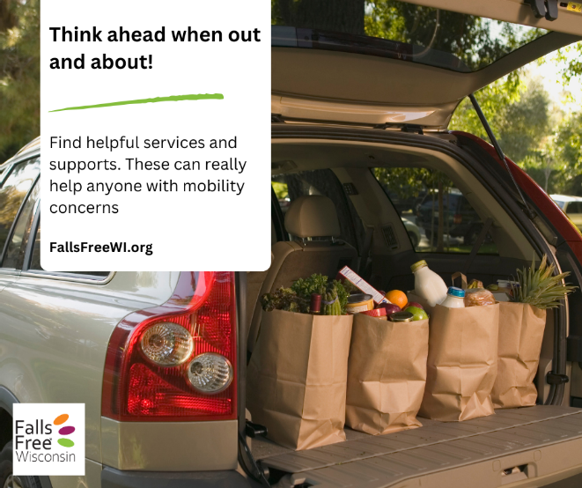 | 💬 Think ahead… can you get delivery, curbside pickup, or help with carrying things to your car when you’re running errands?  These services can help you stay safe by avoiding heavy lifting or walking on slippery and uneven ground. Find out if these helpful options are available at stores and businesses near you.  🔎 Learn simple ways to help prevent falls and support healthy aging: FallsFreeWI.org.  #FallsPreventionAwarenessMonth #FallsPreventionIsATeamEffort #FallsFreeWI
9/17 | 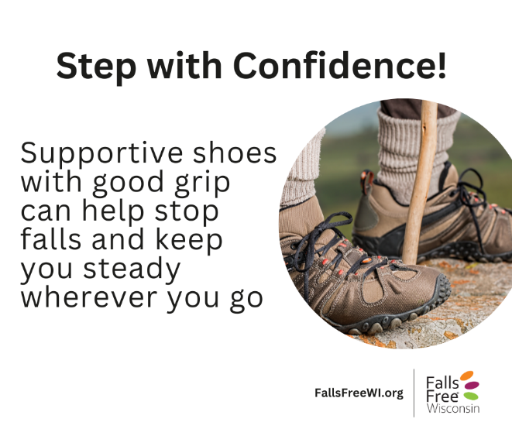 | Wearing the right shoes can go a long way in preventing falls!  ✅ Choose shoes with non-slip soles  ✅ Avoid loose slippers or flip-flops  ✅ Make sure they fit snugly and offer good support  Your shoes should help you move forward — not trip you up!  ✅ Take the next step towards preventing falls—visit FallsFreeWI.org.  #FallsPreventionAwarenessMonth #FallsPreventionIsATeamEffort #FallsFreeWI
9/20 | 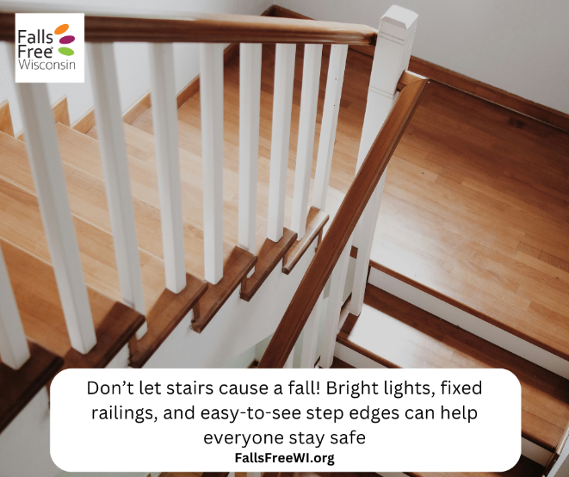 | 🚨 Don’t let stairs cause a fall!  Even small changes can help a lot. Stairs can be tricky—especially if it’s hard to see the steps or if the colors all look the same.  🔹 Put bright tape or paint on the edge of each step  💡 Make sure the stairs have good lighting  🛠️ Use strong railings that are safely attached  These simple fixes help everyone walk up and down stairs more safely.  ✅ Take the next step to prevent falls—visit FallsFreeWI.org.  #FallsPreventionAwarenessMonth #FallsPreventionIsATeamEffort #FallsFreeWI
9/22  *National Falls Prevention Awareness Day! | 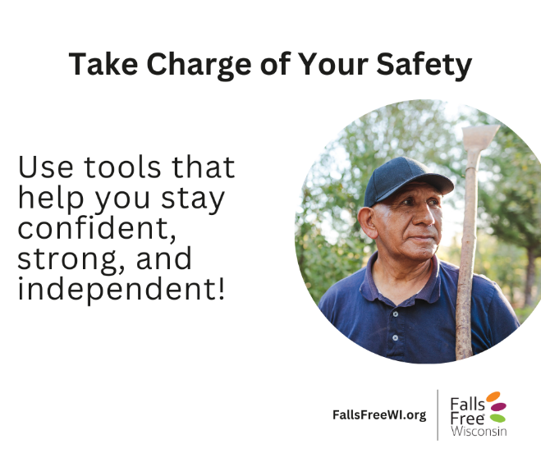 | Using a cane, walker, or hearing aids? That’s smart, not weak!  🩺 Talk to your doctor about how to stay safe from falls  🎧 Have your eyes and ears checked  🆘 Don’t be afraid to ask for help  Staying independent means using tools and asking people you trust when you need help. You’re in charge of your safety — and that’s something to be proud of.  ✅ Take the next step to stop falls—visit FallsFreeWI.org.  #FallsPreventionAwarenessMonth #FallsPreventionIsATeamEffort #FallsFreeWI
9/24 | 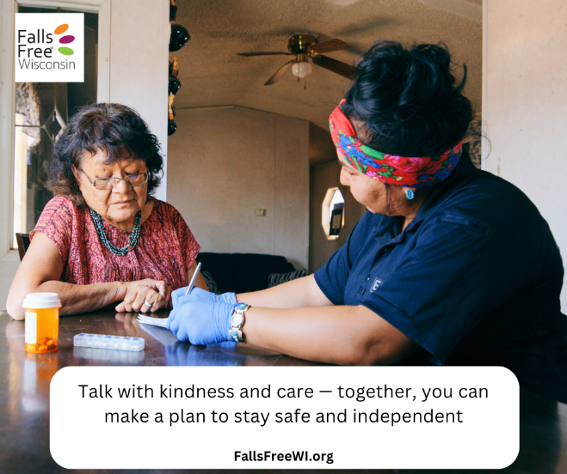 | 🗣 It’s not always easy, but talking about preventing falls shows you care. Ask:  💬 What would help you feel safer at home?  💬 Is there anything I can do to help you stay independent?  Together, you can plan to stay safe and strong. We’re all in this together—learn how you can help at FallsFreeWI.org.  #FallsPreventionAwarenessMonth #FallsPreventionIsATeamEffort #FallsFreeWI
9/26 | 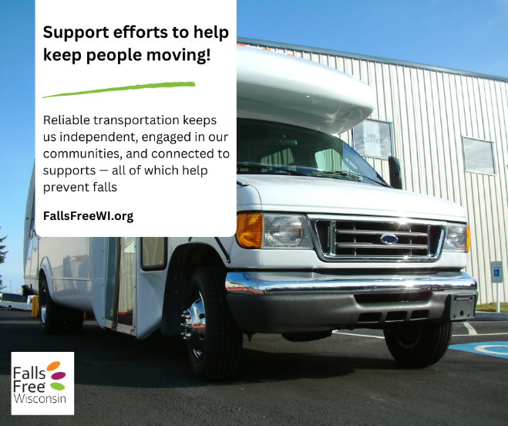 | Having good transportation helps us stay active, get to doctor visits, and stay connected as we age — all important to stop falls.  Let’s support local efforts that offer:  🚗 Ride services  🚌 Public buses, taxis, and trains  🏥 Medical transportation  When we’re connected, our community is safer.  We’re all in this together—learn how you can help at FallsFreeWI.org.  #FallsPreventionAwarenessMonth #FallsPreventionIsATeamEffort #FallsFreeWI
9/28 | 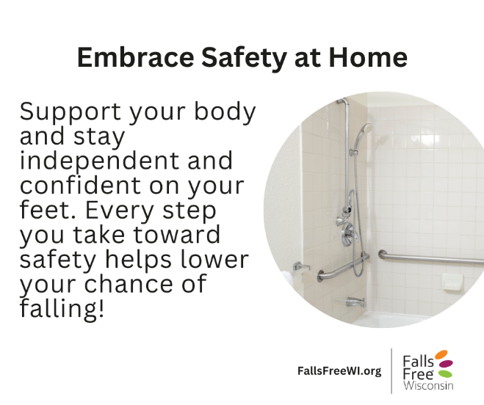 | Small changes around your home can prevent big accidents.  🔧 Install grab bars in the bathroom  💡 Add night lights in hallways and bedrooms  🧹 Declutter walkways  👟 Don’t rush – take your time moving around  These quick fixes can make your home a safer place to thrive! And if you rent – ask your landlord to help you make some of these simple changes to maintain your independence!  ✅ Ready to stay safe and strong? Find tips, tools, and resources at FallsFreeWI.org.  #FallsPreventionAwarenessMonth #FallsPreventionIsATeamEffort #FallsFreeWI
9/29 | 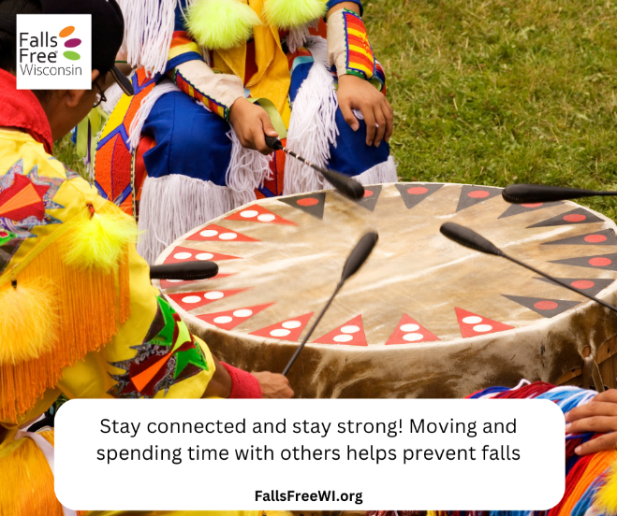 | Stopping falls and staying independent as we age can start with a simple hello.  🤸 Try a community exercise class  🎨 Join social groups and events  📞 Check on your neighbors  Being connected helps us stay active and happy — two great ways to lower the chance of falling!  Let’s be a community that supports each other. We’re all in this together—learn how you can help at FallsFreeWI.org.  #FallsPreventionAwarenessMonth #FallsPreventionIsATeamEffort #FallsFreeWI
9/30 | 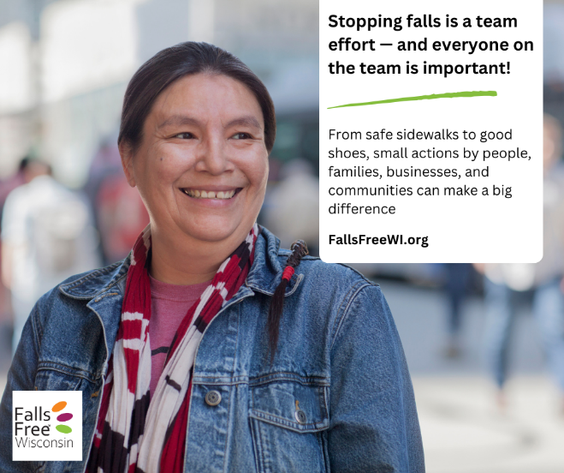 | Stopping falls takes a team — and everyone can help:  👟 Elders: Stay active, wear good shoes, talk to your doctor, and use helpful tools like grab bars, canes, or walkers.  👪 Family & friends: Check in often, help with small jobs like changing light bulbs or organizing medicine, and encourage loved ones to stay safe.  🏪 Businesses: Keep walkways clear, clean up spills fast, offer places to sit, and take away unsafe rugs or clutter.  🏡 Communities: Make transportation easy, keep public places safe, build homes that work for all ages, and offer chances to connect and exercise.  We all have a part in making safer spaces to help everyone stay healthy and independent as we age.  🔎 Find easy ways to stop falls and support healthy aging at FallsFreeWI.org.  #FallsPreventionAwarenessMonth #FallsPreventionIsATeamEffort #FallsFreeWI

