Suggested Date | Asset | Suggested Message for Social Media
12/1 |  | Managing your medications is a great way to stay steady on your feet and prevent falls!  Ask your pharmacist to:  ✅ Review all your prescriptions, supplements, and over-the-counter medications  ✅ Identify side effects that affect balance  ✅ Help adjust timing or doses if needed  Small steps = big safety wins! Find more tips on safely managing medications to stay independent and #FallsFree at FallsFreeWI.org. #FallsFreeWI #MedicationManagement
12/4 | 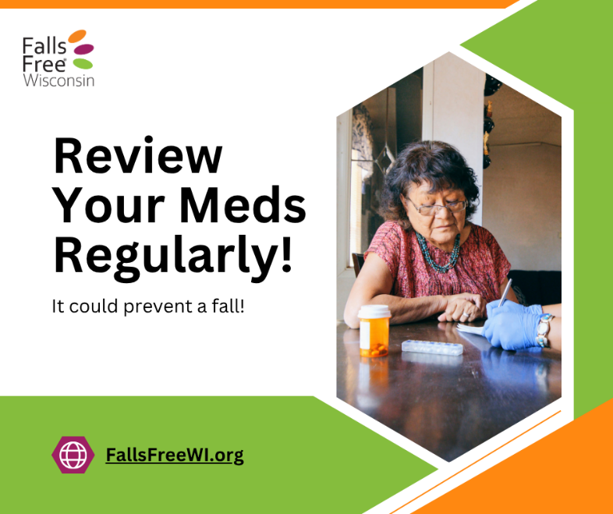 | Many older people take multiple medications — but some combinations can cause dizziness, drowsiness, or confusion that increases fall risk. Regular medication reviews can help us stay independent and confident on our feet as we age.  Find more tips on safely managing medications to stay independent and #FallsFree at FallsFreeWI.org. #FallsFreeWI #MedicationManagement
12/7 |  | Do you know what medications you take — and why? 💊  It’s easy to lose track of what each medication you take does – but understanding your meds is a key part of staying steady on your feet! Some prescriptions and even over-the-counter meds can cause dizziness or drowsiness, increasing your risk of falls.  👉 Keep an updated medication list, ask questions, and talk with your pharmacist or doctor about any side effects. Find more tips on safely managing medications to stay independent and #FallsFree at FallsFreeWI.org. #FallsFreeWI #MedicationManagement
12/12 |  | Falls prevention is a team effort! Your pharmacist, doctor, and care team can all help make sure your medications keep you healthy — not dizzy or off-balance. Take a few minutes this week to review your meds and protect your independence.  Find more tips on safely managing medications to stay independent and #FallsFree at FallsFreeWI.org. #FallsFreeWI #MedicationManagement
12/16 |  | Taking your medications exactly as directed helps you stay healthy — and on your feet! 💊👣  Skipping doses or mixing meds the wrong way can cause dizziness, fatigue, or confusion, which can all raise your risk of falling.  Follow the label, ask questions, and talk with your pharmacist if something doesn’t feel right. Find more tips on safely managing medications to stay independent and #FallsFree at FallsFreeWI.org. #FallsFreeWI #MedicationManagement
12/19 | 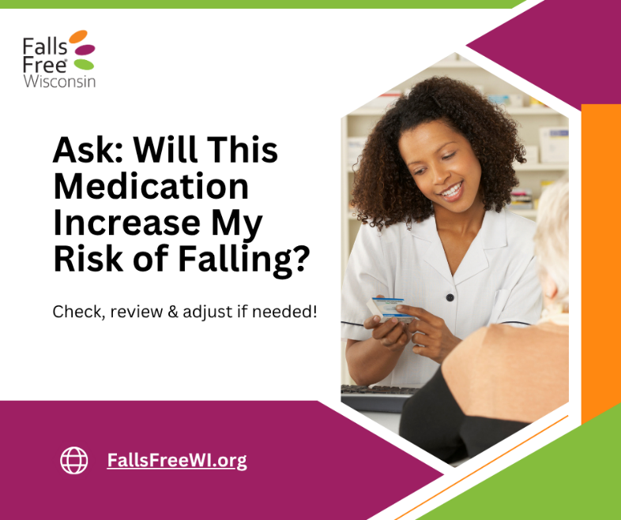 | Tip: Keep a current list of ALL your medications, including:  ✅ Prescription drugs  ✅ Over-the-counter medicines (like pain relievers or allergy pills)  ✅ Vitamins and herbal supplements  AND share it with your healthcare team. This simple step helps them spot possible side effects or interactions that can increase your risk of falling.  Find more tips on safely managing medications to stay independent and #FallsFree at FallsFreeWI.org. #FallsFreeWI #MedicationManagement
12/22 |  | Sometimes the best medicine isn’t in a bottle — it’s in a brush, a song, or a walk with friends! 🎨🎶🚶‍♀️  Creative activities, exercise, and mindfulness can help ease pain, boost mood, and improve balance — all while reducing your risk of falls.  Talk with your healthcare provider about safe, non-medication ways to support your health and well-being. Find more tips on safely managing medications to stay independent and #FallsFree at FallsFreeWI.org. #FallsFreeWI #MedicationManagement
12/27 |  | When we say “medications,” we mean all of them — not just prescriptions! That includes:  ✅ Prescription drugs  ✅ Over-the-counter medicines (like pain relievers or allergy pills)  ✅ Vitamins and herbal supplements  Even common or “natural” products can interact or increase your risk of dizziness and falls. Keep a full list of everything you take and share it with your doctor or pharmacist.  Find more tips on safely managing medications to stay independent and #FallsFree at FallsFreeWI.org. #FallsFreeWI #MedicationManagement
12/29 | 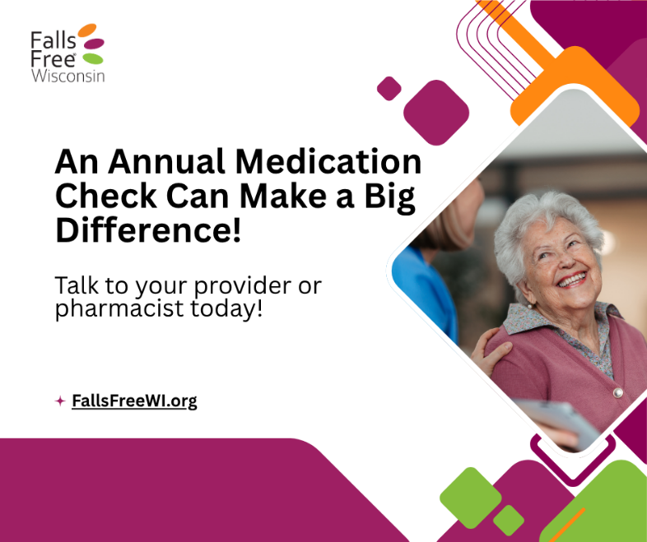 | When was your last medication check? A quick, yearly review with your doctor or pharmacist helps make sure your prescriptions, over-the-counter meds, and supplements are still right for you.  Even small changes, if needed, can reduce dizziness, confusion, and falls – helping you stay confident and independent!  Find more tips on safely managing medications to stay independent and #FallsFree at FallsFreeWI.org. #FallsFreeWI #MedicationManagement

