Suggested Date | Asset | Suggested Message for Social Media
2/1 | 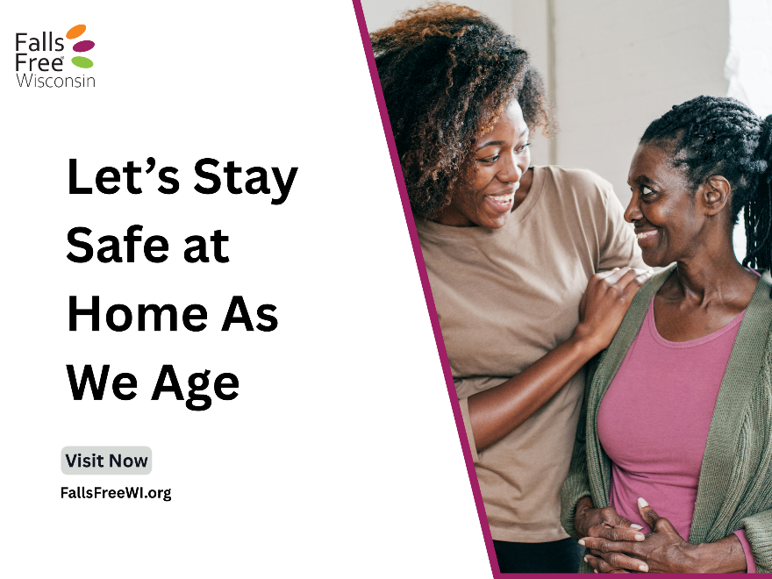 | Falls are preventable, and home safety plays a big role. If you’re supporting an aging parent, partner, or friend, or worried about your own risk of falling, small changes at home can make a big difference in helping us stay safe, confident, and independent.  Not sure where to start? Whether you’re a caregiver or older adult, find tips for having conversations about falls here: https://fallsfreewi.org/prevent-falls/conversations/. Approach the conversation with kindness, honesty, and care so everyone feels heard. #FallsFreeWI
2/4 | 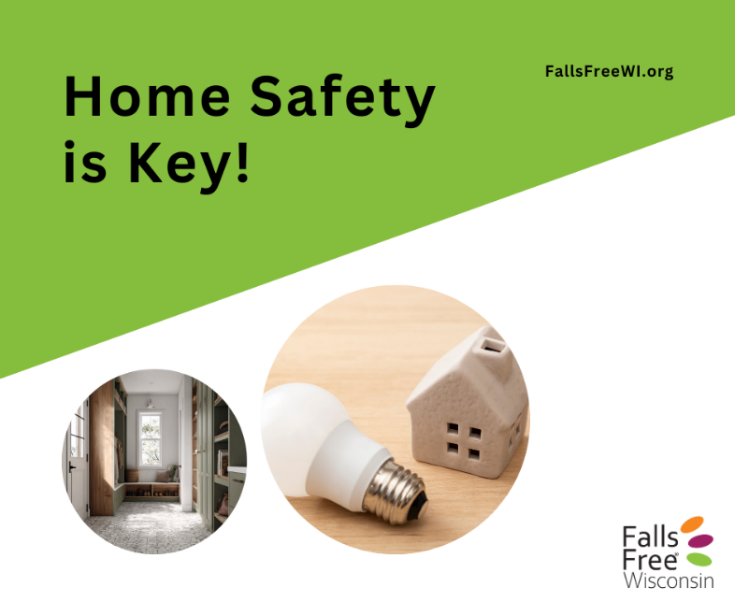 | Clutter can be more than just messy — it can increase the risk of falls and make it harder to stay safe at home. 🏠  If you or someone you care about struggles with hoarding or excess clutter, you’re not alone. Small, respectful steps can make a big difference. Clearing walkways, improving lighting, and creating safe paths through the home can help reduce fall risks while honoring comfort and independence.  Home safety starts with understanding, patience, and support. Learn how addressing clutter can protect mobility, confidence, and well-being — and help everyone age safely at home: https://fallsfreewi.org/stronger-together-building-falls-resiliency-at-home/. #FallsFreeWI
2/9 | 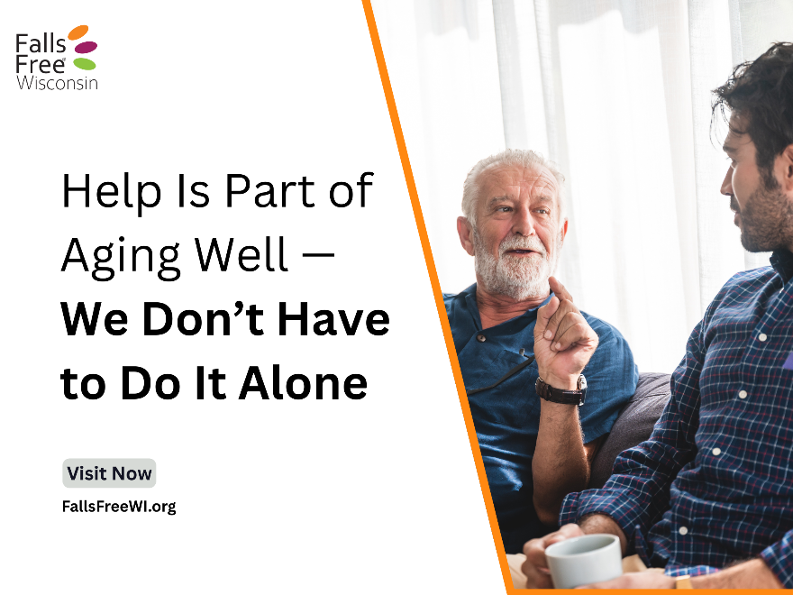 | It’s okay to ask for help! Building resiliency against falling isn’t something you have to do alone. Asking for help—whether from family, friends, or a caregiver—is a sign of strength, not weakness.  ✅ Need help clearing clutter or installing grab bars?  ✅ Want someone to change a lightbulb or add non-slip mats?  ✅ Looking for guidance on exercises to stay steady?  Reach out. Accepting support can help keep us safe and independent at home.  Caregivers—don’t forget about YOU! Preventing falls means you can keep caring for others with strength and confidence. Find tips here: https://fallsfreewi.org/prevent-falls/caregivers/. #FallsFreeWI
2/13 | 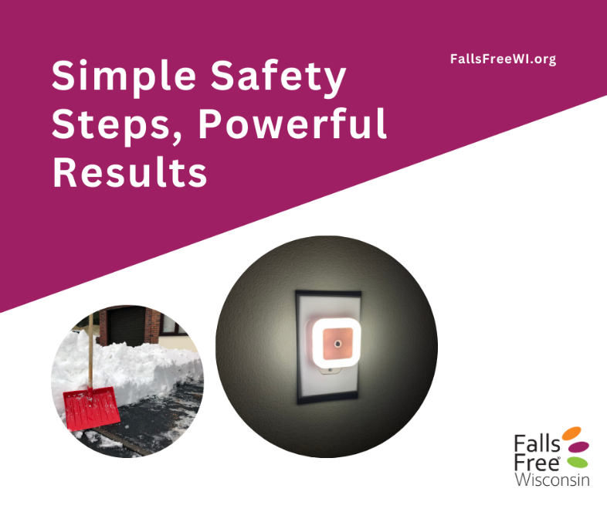 | Preventing falls at home doesn’t have to be complicated. Simple adjustments can make a huge difference:  ✅ Keep pathways clear of clutter  ✅ Add nightlights in hallways and bathrooms  ✅ Use non-slip mats in the shower or tub  ✅ Secure loose rugs and get rid of throw rugs that bunch up  ✅ Install grab bars near toilets and in the shower  A few small steps today can prevent a life-changing fall. Stay safe and move with confidence in your home! Take the Home Safety Challenge for more tips: https://fallsfreewi.org/prevent-falls/surround/interactive-home-walk-through/. #FallsFreeWI
2/16 | 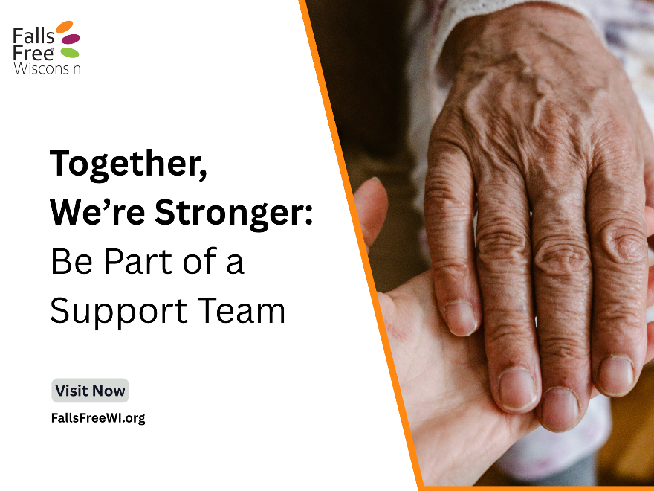 | Addressing hoarding and fall risks isn’t something anyone should do alone. When we work as a team—family members, friends, caregivers, and professionals—we can create safer homes while respecting dignity and independence.  Collaboration helps identify hazards, set realistic goals, and make gradual changes that improve falls resiliency and quality of life.  Together, we can support safer living spaces that help us stay confident and secure at home as we age. Learn more here: https://fallsfreewi.org/stronger-together-building-falls-resiliency-at-home/ #FallsFreeWI
2/19 | 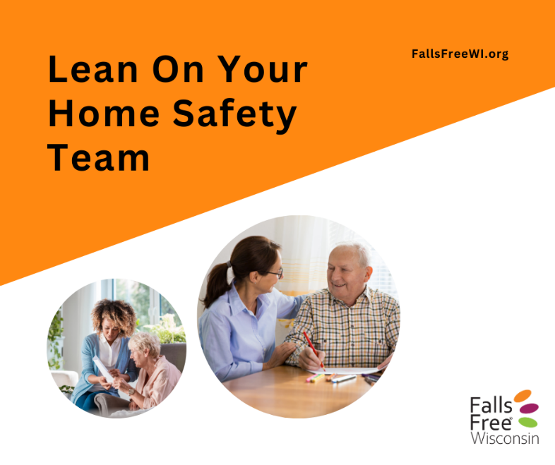 | As we age, preventing falls is easier when we have support. Your home safety team—family, caregivers, friends, neighbors, healthcare providers, and community agencies—can help:  ✅ Suggest simple changes to reduce risk  ✅ Assist in making home safety modifications  ✅ Provide tools and strategies to stay safe and confident – like access to exercise classes or health promotion programs  ✅ Offer encouragement and support every step of the way  You don’t have to do it alone. Together, you and your home safety team can help you move through life safely and independently.  Take the Home Safety Challenge for ideas on where to start: https://fallsfreewi.org/prevent-falls/surround/interactive-home-walk-through/. #FallsFreeWI
2/22 | 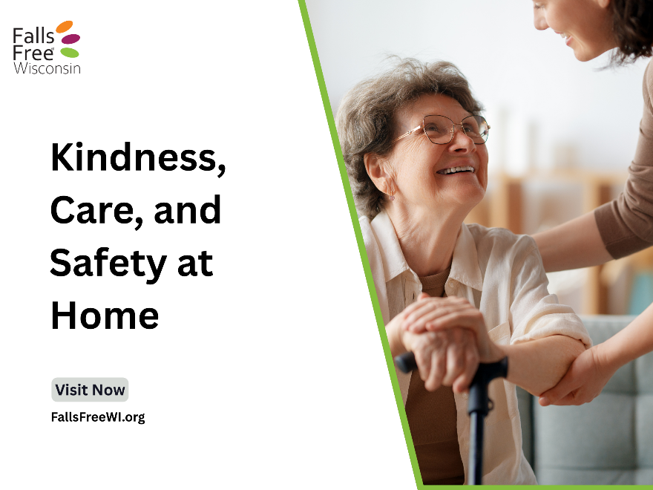 | Preventing falls at home starts with understanding the needs of others, not just sharing our own opinions. By listening carefully, we can:  ✅ Identify what matters to them  ✅ Understand their comfort and mobility challenges  ✅ Assist in coming up with solutions that fit their routines and preferences  ✅ Empower them to feel confident and safe in their own home  Every voice matters. When the people we talk to feel heard, we can work together to address concerns with kindness and care.  Whether you’re a caregiver or older adult, find tips for having conversations about falls here: https://fallsfreewi.org/prevent-falls/conversations/. #FallsFreeWI
2/26 | 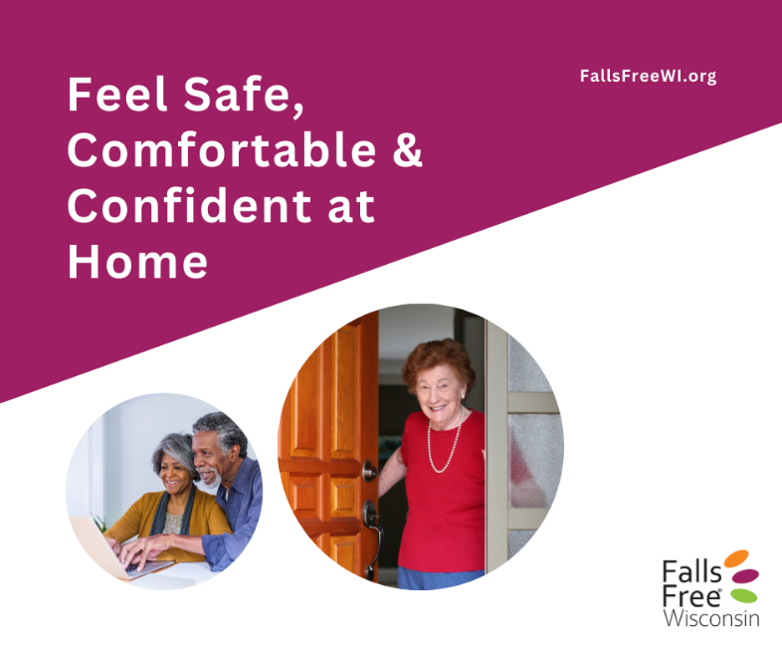 | Home safety matters—for everyone! 🏡  This month, we’ve talked about:  - Improving safety at home to build falls resiliency  - Supporting older adults and caregivers  - Understanding the impact of clutter and hoarding on safety and risk of falls  The takeaway? Small changes, kindness, compassion, teamwork, and asking for help make a big difference. Caregivers, older adults, family members, and professionals all play a role in creating and maintaining safe and comfortable homes.  Let’s keep the conversation—and the care—going! Visit FallsFreeWI.org for more. #FallsFreeWI

