You will need a measurement device in inches.
The FRT is an indicator of limits of stability. It is meant to determine the distance that a person can move his/her center of gravity in the anterior direction before needing to take a compensatory step.
Safety first!
Have client stand next to a wall free of obstructions with the feet hip width apart. The dominant arm should be closest to the wall. Have client extend his/her arm to the front at 90 degree angle (to shoulder height). The client should not touch the wall or measurement device. Client should reach forward without taking a step. Measurement based on subtracting starting point from ending position.

Pass: If reach is greater than 10 inches subject is unlikely to fall
Fail: if reach is < 10 inches (note: 6-10 inches, 2x more likely to fall; < 6 inches, 4x more likely to fall)
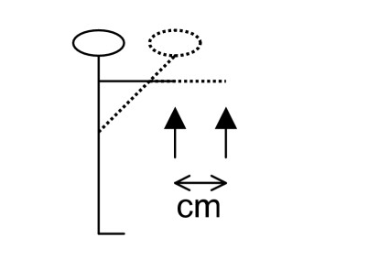
Inches

