Suggested Date | Asset | Suggested Message for Social Media
5/1 | 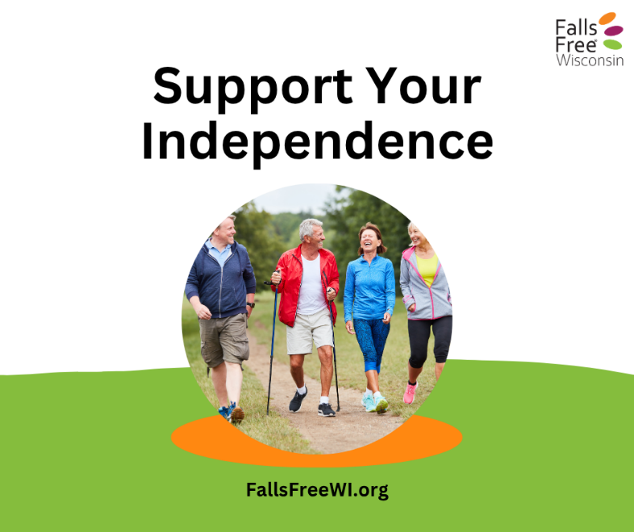 | Staying active and independent as we age is so important—and sometimes, a little extra support can make all the difference.  Walking sticks and canes can provide the support we need to stay active, mobile, and independent—so we can keep doing the things we love.  Find more tips at http://fallsfreewi.org/prevent-falls/assistive-devices/ #FallsFreeWI
5/4 | 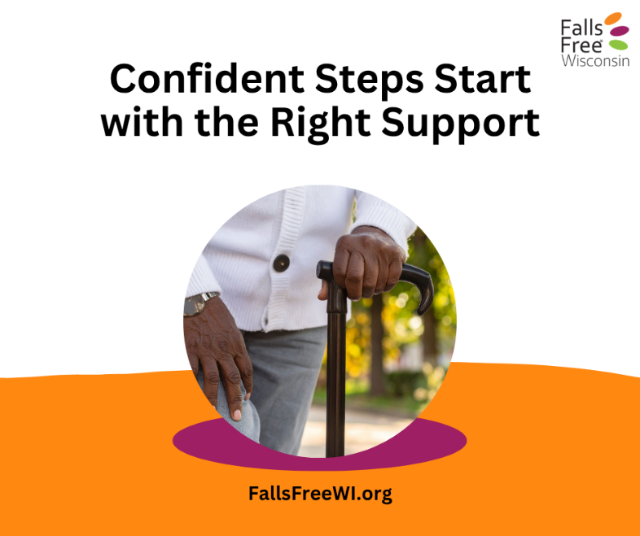 | We often get outside more as the weather warms up—but uneven ground, gravel paths, and grassy areas can make it harder to feel steady.  Using a cane can give us extra support to walk with confidence. It helps with balance, reduces the risk of falls, and makes it easier to enjoy time outdoors.  A cane isn’t holding us back—it’s helping us to keep moving forward. Learn more at http://fallsfreewi.org/prevent-falls/assistive-devices/ #FallsFreeWI
5/9 | 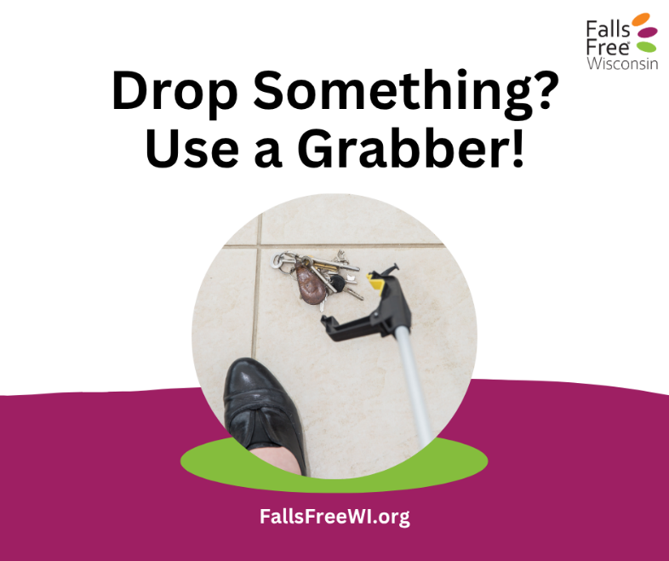 | Dropped something on the floor? No need to risk a fall trying to reach it. Using a grabber or reacher can help you pick things up safely—without bending, stretching, or risking losing your balance.  It’s a simple tool that can make a big difference in protecting your safety and independence.  Find more tips at http://fallsfreewi.org/prevent-falls/assistive-devices/ #FallsFreeWI
5/13 | 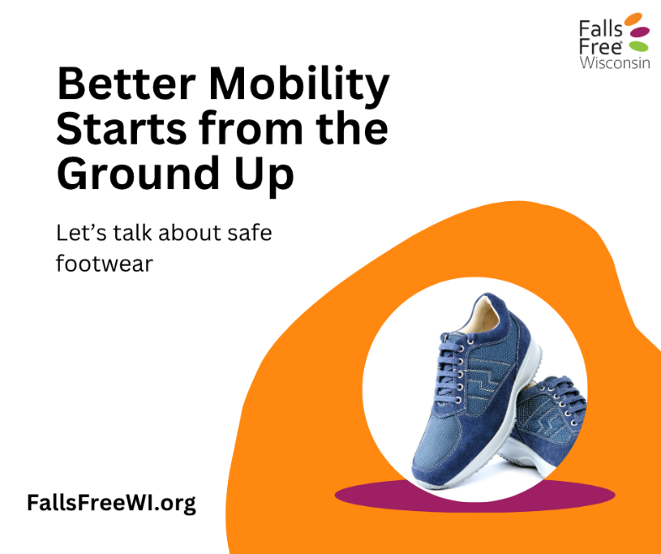 | Step outside with confidence! Whether it’s a stroll around the block, a walk in the park, or just enjoying fresh air, the right footwear makes all the difference.  Supportive shoes help you stay stable, reduce slips and trips, and make every step more comfortable.  Don’t let the wrong shoes hold you back—pick footwear that fits well, supports your feet, and is ready for the great outdoors. Learn more about the features of safe and unsafe shoes at https://fallsfreewi.org/prevent-falls/footwear/ #FallsFreeWI
5/16 | 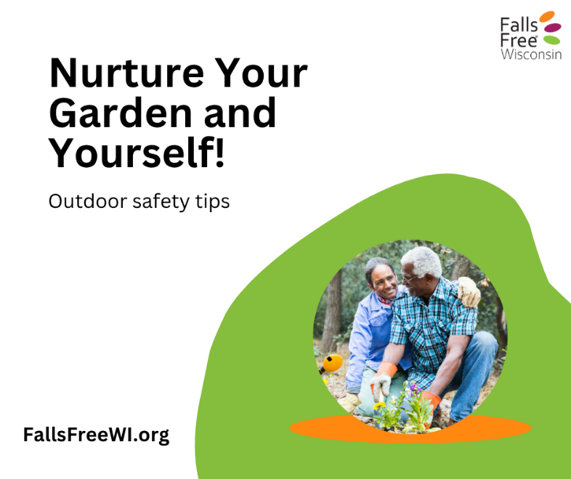 | Spending time outside—whether gardening, cheering on your grandkids at their sporting events, or just taking a stroll or running errands—should be fun and safe. Here are a few tips to keep you steady and comfortable:  - Wear supportive, non-slip footwear  - Stay hydrated, especially on warm days  - Take breaks and sit when you need to  - Be mindful of uneven surfaces and obstacles  A little preparation goes a long way in keeping outdoor time enjoyable and injury-free. Get out there and soak up the sunshine safely!  Learn more at FallsFreeWI.org. #FallsFreeWI
5/19 | 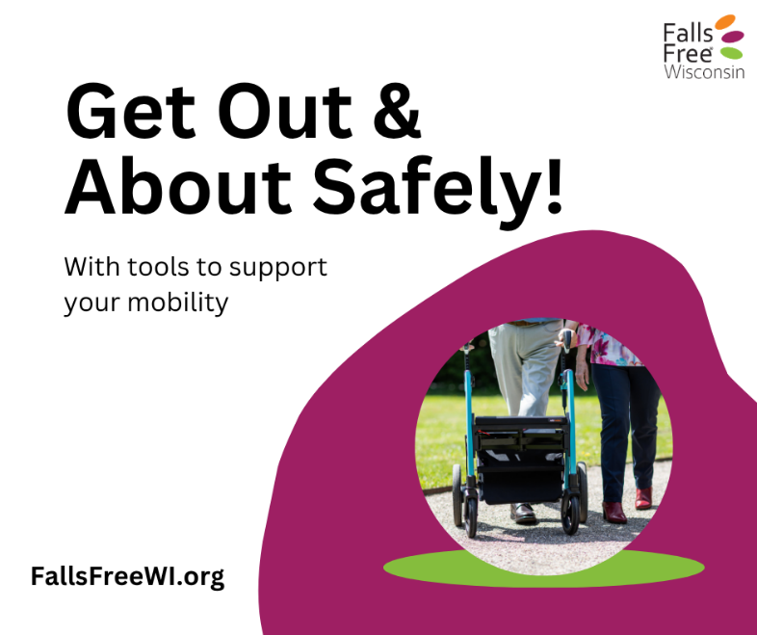 | Who says getting around can’t be fun? Whether it’s a sturdy cane, trusty walker, or favorite walking stick, the right support keeps you moving with confidence—and a little extra style!  From taking grandkids to the park to exploring your favorite trails, these mobility helpers let you enjoy every step safely. Don’t just get by—get out there and OWN your adventures!  Find more tips at http://fallsfreewi.org/prevent-falls/assistive-devices/ #FallsFreeWI
5/22 | 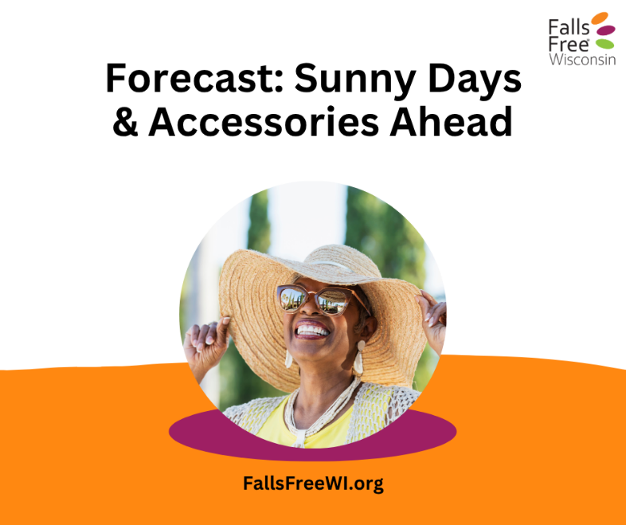 | Sunny days are perfect for walks and outdoor fun, but bright light and glare can make it harder to spot bumps, curbs, or uneven ground. Protect your eyes with sunglasses or a brimmed hat, take your time, and stay aware of the path ahead.  Enjoy the outdoors safely—every step counts! Learn more at FallsFreeWI.org. #FallsFreeWI
5/26 | 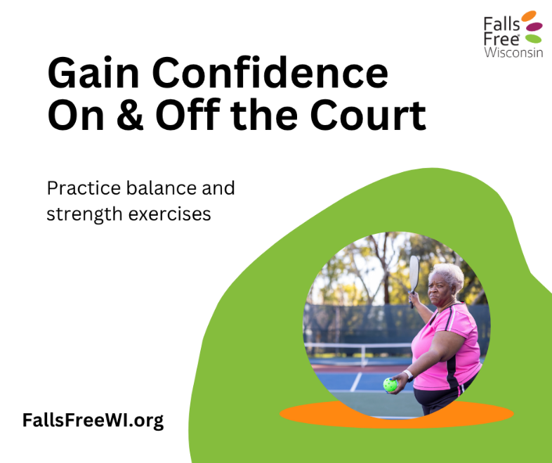 | A little balance and strength practice each day goes a long way—helping you move confidently while running errands, carrying groceries, or chasing a ball on the pickleball court.  Simple exercises keep your muscles strong, your steps steady, and your days worry-free.  Find some simple balance and strength exercises to incorporate into your routine at https://fallsfreewi.org/prevent-falls/balance-strength/. #FallsFreeWI
5/29 | 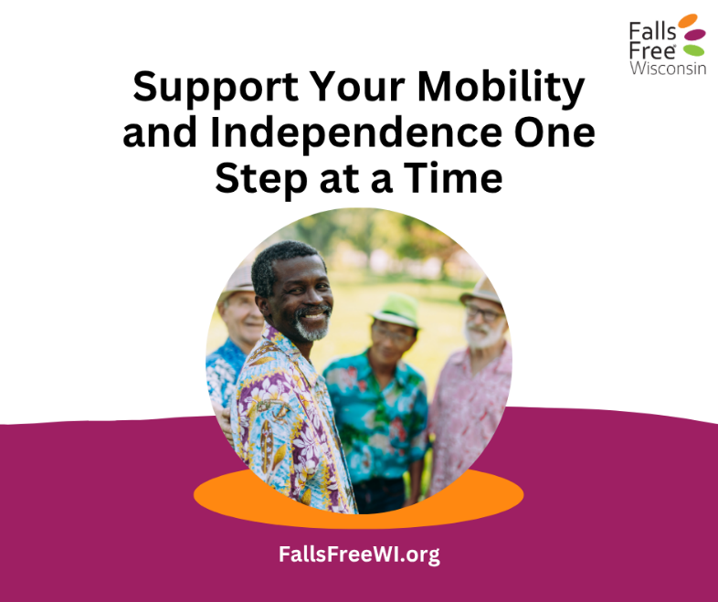 | Getting out and about should be fun—not risky. Simple steps can make a big difference:  - Use mobility aids like canes, walkers, or walking sticks for stability  - Wear supportive, non-slip footwear  - Protect your eyes and watch for glare  - Stay aware of obstacles and uneven ground  - Practice balance and strength exercises  A little preparation goes a long way in keeping us steady and confident as we age. Find more tips at FallsFreeWI.org. #FallsFreeWI

