Date | Asset | Suggested Message for Social Media
9/1 | 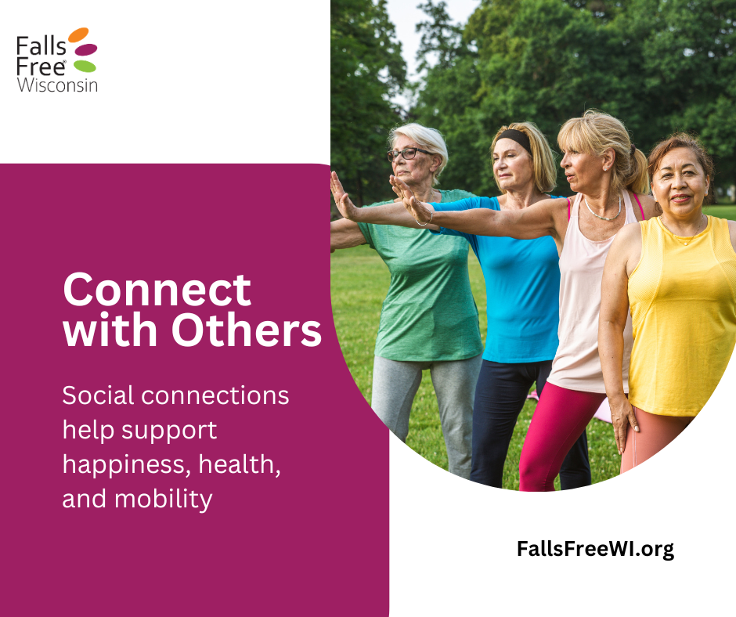 | September is Falls Prevention Awareness Month! Let’s make social connection a priority this month and beyond to help reduce our risk of falls and stay steady as we age.  Staying connected isn’t just good for our mood, it’s an important part of our overall health. Social connections can support habits that lower our risk of falls, like staying active, and making safe, healthy choices.  Whether it’s joining a class with a friend, going for a walk together, or simply checking in with someone you care about, those small moments of connection add up to better mobility and greater confidence.  Find tips to reduce our risk of falls at FallsFreeWI.org and meaningful ways to connect at ConnectWI.org.  #FallsPreventionAwarenessMonth #StaySteadyStayConnected #FallsFreeWI
9/3 | 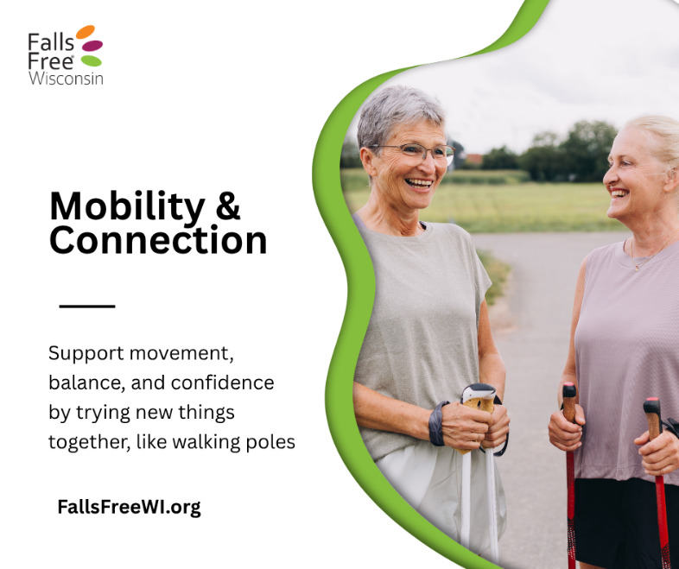 | Mobility looks different for everyone—and the right support can make all the difference.  Canes, walkers, and other mobility aids are tools that help us stay steady, confident, and independent. Friends, family, and community support can encourage us to stay active, try new things, and keep doing what we enjoy.  When we combine the right mobility aids with strong social connections, we create more opportunities to move safely, stay engaged, and continue living life fully.  Find more information about mobility aids at FallsFreeWI.org/assistive-devices. #FallsPreventionAwarenessMonth #StaySteadyStayConnected #FallsFreeWI
9/6 | 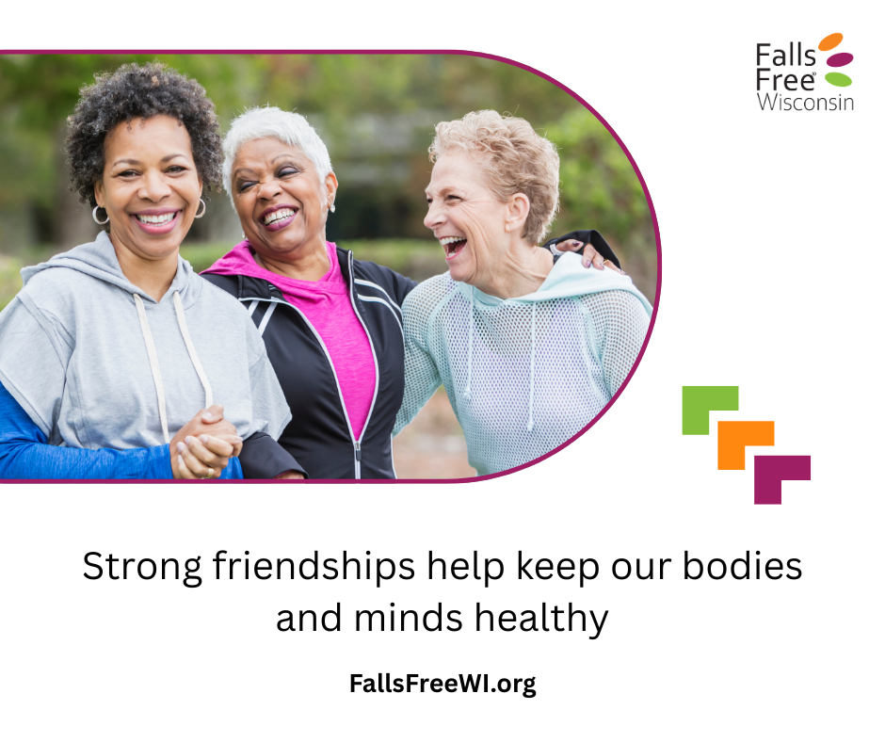 | Strong friendships do more than bring joy, they can also play a role in helping us stay steady and safe as we age.  Friends encourage us to stay active, try new things, and keep moving. They remind us to take care of ourselves, check in when something feels off, and even lend a hand when needed. Those everyday moments of connection can support habits that help reduce our risk of falls.  Whether it’s walking together, attending a class, or simply checking in on each other, strong friendships help build confidence, mobility, and support systems that matter.  Find tips to reduce our risk of falls at FallsFreeWI.org and meaningful ways to connect at ConnectWI.org.  #FallsPreventionAwarenessMonth #StaySteadyStayConnected #FallsFreeWI
9/8 | 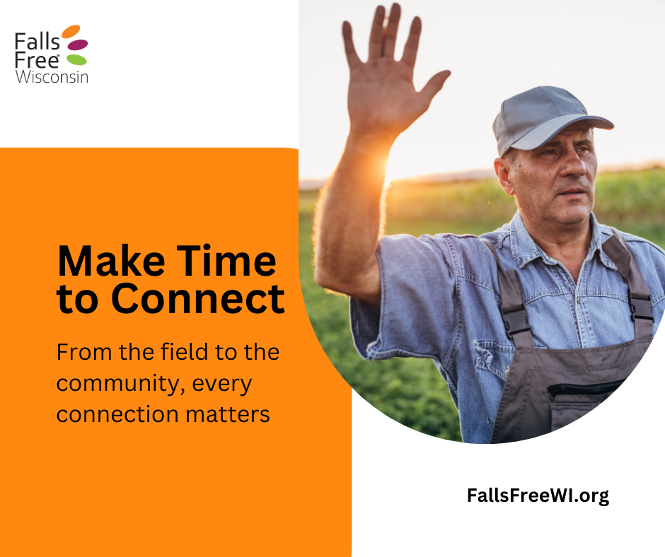 | From working in the field to serving in the community or spending time with friends and family, these moments of connection help keep us active, engaged, and supported.  Strong social ties encourage movement, build confidence, and help create routines that support safer, steadier living—all of which can play a role in building falls resiliency.  Connection doesn’t stop when the work ends—it carries through everything we do. And the more we stay connected, the stronger and steadier we all become.  Find tips to reduce our risk of falls at FallsFreeWI.org and meaningful ways to connect at ConnectWI.org.  #FallsPreventionAwarenessMonth #StaySteadyStayConnected #FallsFreeWI
9/10 | 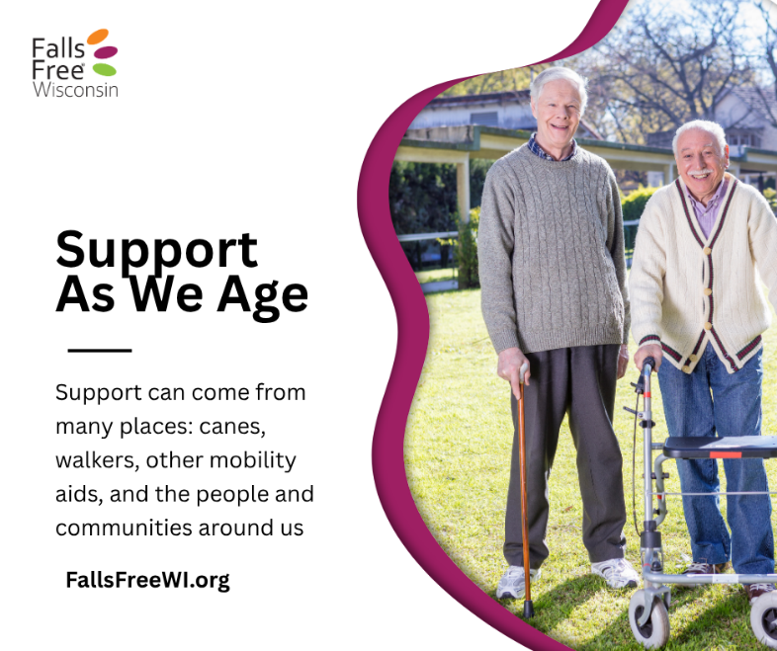 | Mobility aids like canes, walkers, and other supportive devices can help us stay confident, steady, and independent as we get out and about in our communities.  Whether it’s running errands, meeting a friend for coffee, attending an event, or taking a walk outside, mobility aids can help make those everyday moments safer and more accessible.  Staying active in our communities also helps us stay connected, engaged, and supported. When we combine the right tools with opportunities to get out and connect, we open the door to greater independence and quality of life.  Find more information about mobility aids at FallsFreeWI.org/assistive-devices. #FallsPreventionAwarenessMonth #StaySteadyStayConnected #FallsFreeWI
9/12 | 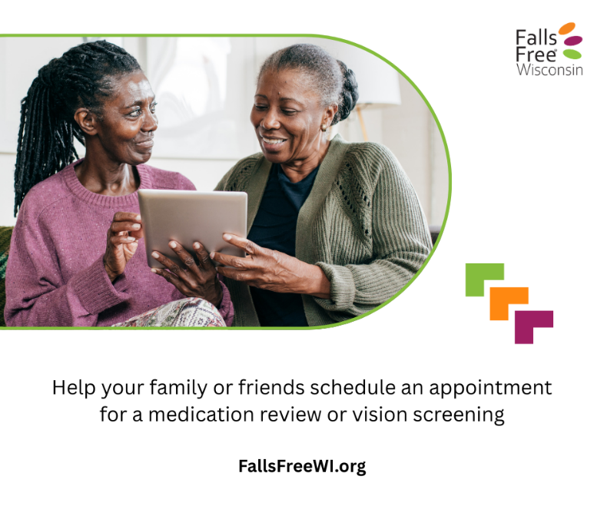 | Helping a family member or friend schedule a medical appointment—whether it’s for a medication review, vision check, or routine visit—is a simple act of connection that can make a big difference.  A little support goes a long way in helping the people we care about stay well and stay independent.  We’re all in this together! Learn how you can help at FallsFreeWI.org. #FallsPreventionAwarenessMonth #StaySteadyStayConnected #FallsFreeWI
9/14 | 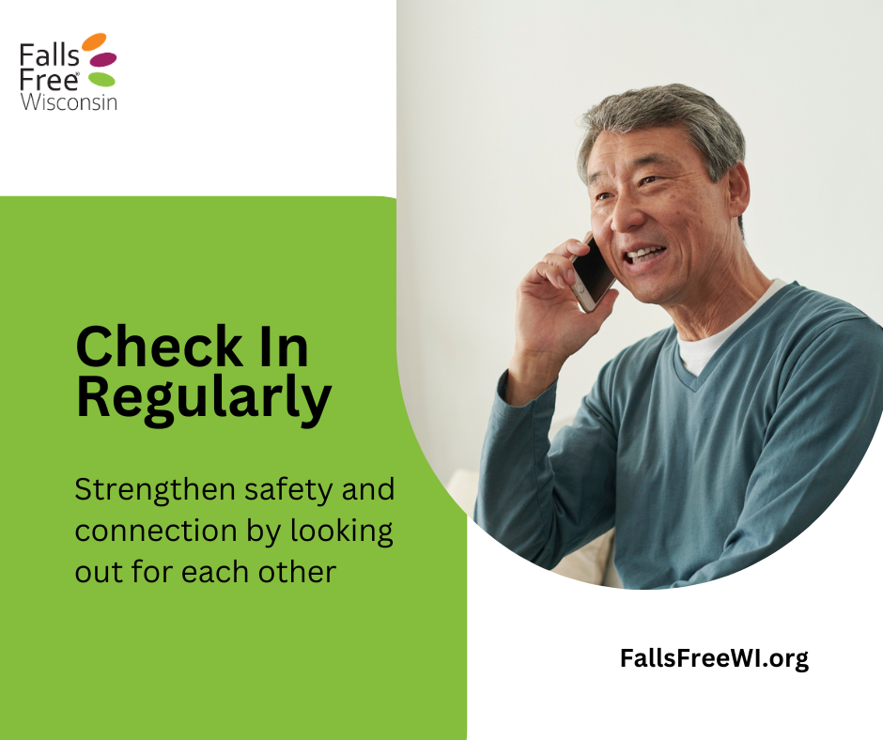 | Checking in with the people in our lives is a simple habit that can make a big difference.  A quick call, text, or visit can help us notice if something feels “off,” offer support early, and encourage healthy habits that keep us steady and active. These small moments of connection can help reduce loneliness and isolation and even play a role in preventing falls!  When we check in on each other, we’re not just staying connected—we’re helping create safer, stronger, more resilient communities.  Find tips to reduce our risk of falls at FallsFreeWI.org and meaningful ways to connect at ConnectWI.org.  #FallsPreventionAwarenessMonth #StaySteadyStayConnected #FallsFreeWI
9/17 | 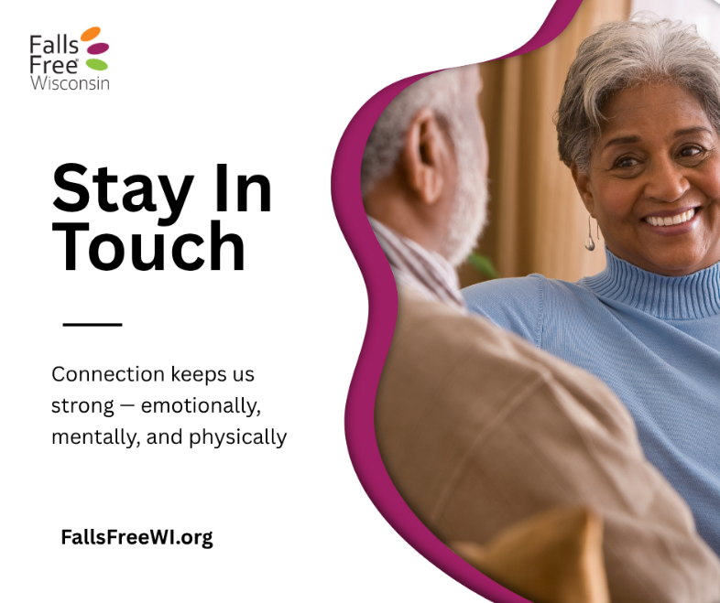 | Staying connected with friends, family, and community can encourage us to stay active, build confidence, and maintain daily routines that support strength and balance.  Something as simple as a walk with a friend, a shared activity, or a regular check-in can go a long way in supporting our well-being and increase our resilience as we age.  Find tips to reduce our risk of falls at FallsFreeWI.org and meaningful ways to connect at ConnectWI.org.  #FallsPreventionAwarenessMonth #StaySteadyStayConnected #FallsFreeWI
9/20 | 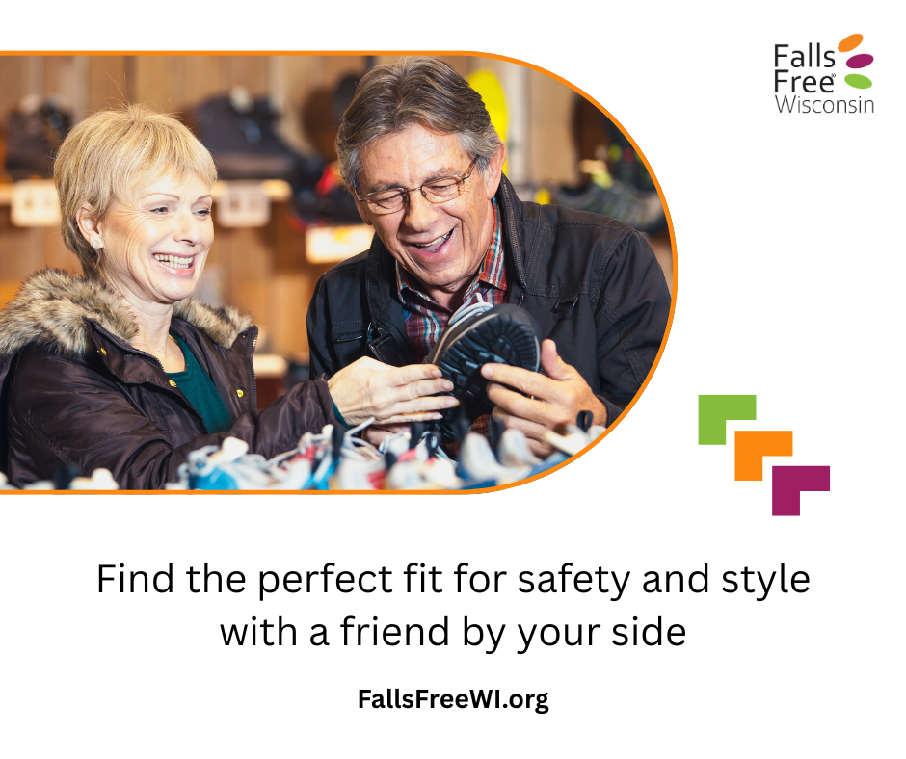 | Choosing the right footwear is an important part of reducing our risk of falls, helping us stay steady, supported, and confident on our feet. Bringing a friend along can make the experience even better—they can offer a second opinion, help spot supportive features, and turn a simple shopping trip into a chance to connect.  It’s a great reminder that healthy choices are often easier, and more enjoyable, together.  Find more information about safe footwear at FallsFreeWI.org/footwear. #FallsPreventionAwarenessMonth #StaySteadyStayConnected #FallsFreeWI
9/22  *National Fall Prevention Awareness Day! | 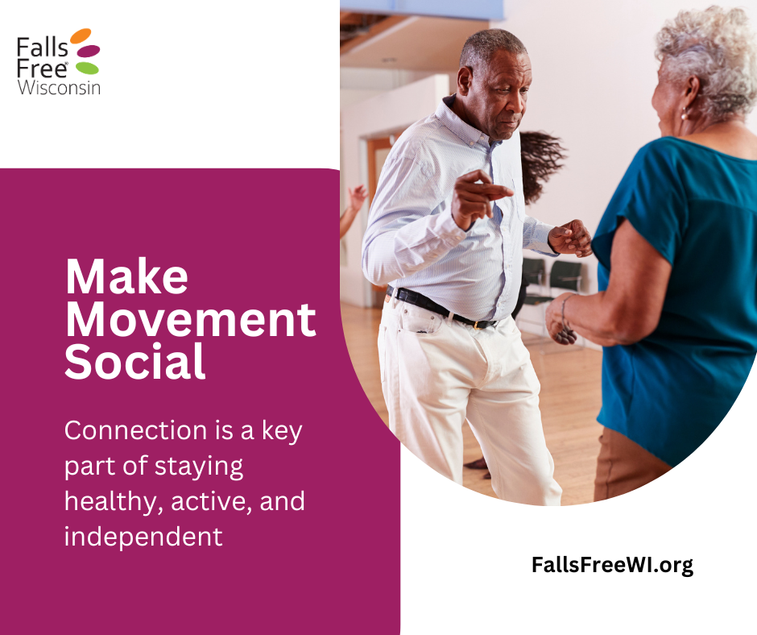 | Whether it’s walking with a friend, joining a group class, dancing at an event, or simply getting outside together, moving with others helps build connection, boost motivation, and support overall well-being. These shared moments can also encourage consistency and confidence—key factors in staying strong and reducing our risk of falls as we age.  When we make movement social, it doesn’t feel like a chore—it becomes an opportunity for stronger connections, steadier bodies, and lasting memories.  Find tips to reduce our risk of falls at FallsFreeWI.org and meaningful ways to connect at ConnectWI.org.  #FallsPreventionAwarenessMonth #StaySteadyStayConnected #FallsFreeWI
9/25 | 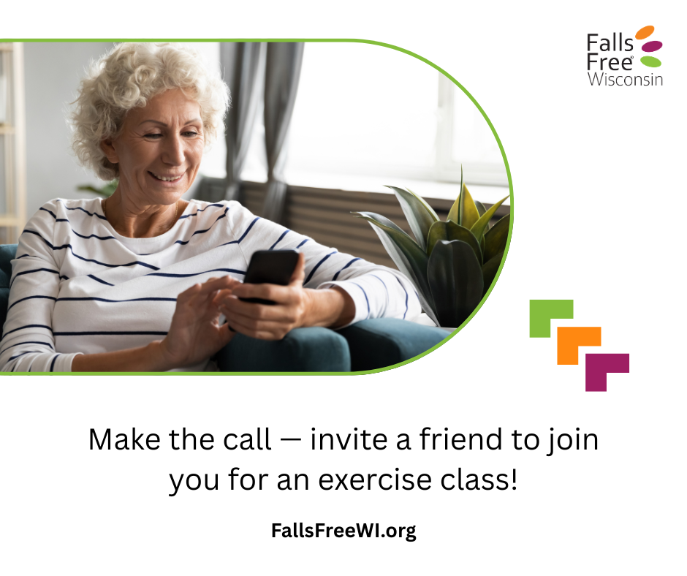 | Inviting someone to join you for an exercise class can turn movement into connection—making it more enjoyable, more motivating, and more consistent. Whether it’s strength, balance, or flexibility, moving together helps build confidence and supports healthier, steadier living.  Plus, it’s a great way to catch up, laugh a little, and encourage each other along the way.  So, make the call or send the text, and invite a friend to join you. You’ll be glad you did.  Find more information about balance and strength exercises at FallsFreeWI.org/balance-strength. #FallsPreventionAwarenessMonth #StaySteadyStayConnected #FallsFreeWI
9/28 | 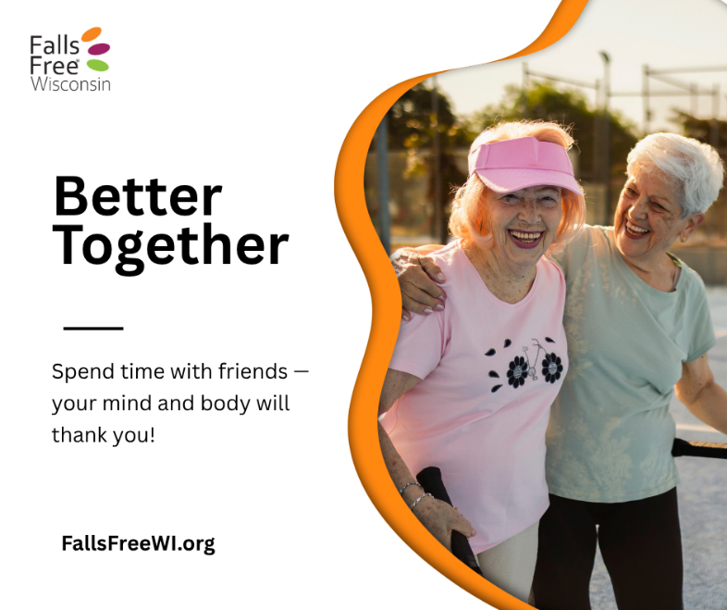 | Spending time with friends does more than lift our mood, it can also support healthy aging.  Whether it’s going for a walk, joining a community event, or simply catching up, time with friends helps keep us active, engaged, and connected. These everyday moments can encourage movement, build confidence, and support routines that help reduce our risk of falls and stay steadier, both physically and emotionally.  Find tips to reduce our risk of falls at FallsFreeWI.org and meaningful ways to connect at ConnectWI.org.  #FallsPreventionAwarenessMonth #StaySteadyStayConnected #FallsFreeWI
9/30 | 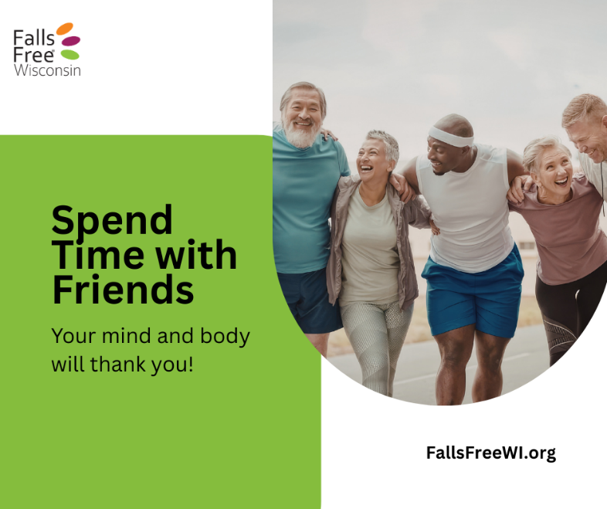 | As Falls Prevention Awareness Month ends, one message stands out: we’re stronger and safer when we stay connected.  Social connection plays an important role in healthy aging. Staying in touch with friends, family, and community helps us stay active, build confidence, and maintain routines that support balance and mobility. These everyday connections can also help reduce loneliness and isolation and encourage habits that lower our risk of falls and increase our resilience.  From sharing a walk to checking in on each other, small moments of connection make a big difference.  Let’s carry this momentum forward—because staying mobile and independent isn’t just about physical health, it’s about staying connected all year long.  Find tips to reduce our risk of falls at FallsFreeWI.org and meaningful ways to connect at ConnectWI.org.  #FallsPreventionAwarenessMonth #StaySteadyStayConnected #FallsFreeWI

