Date | Asset | Suggested Message for Social Media
11/1  *American Diabetes Month | 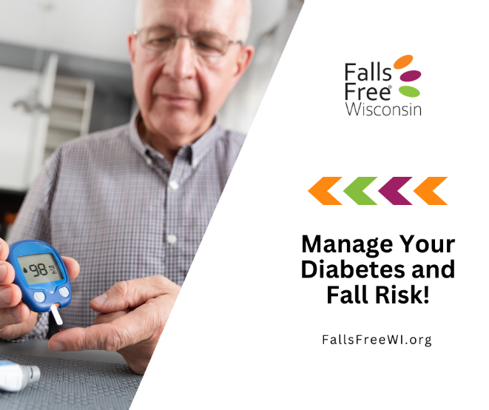 | Managing your diabetes can also help reduce your risk of falls. That’s why it’s important to:  ▪️ Wear supportive, well-fitting shoes  ▪️ Schedule regular eye exams and foot checks  ▪️ Stay active with exercises that improve strength and balance  ▪️ Manage your blood sugar and talk with your healthcare provider about your medications and risk of falling  Diabetes can affect vision, balance, sensation in your feet, and muscle strength. Consider taking a Healthy Living with Diabetes workshop—proven to improve A1C levels and help you better manage your health! Learn more and find a workshop near you at https://wihealthyaging.org/programs/live-well-programs/hlwd/.  Find more tips to reduce your risk of falls at FallsFreeWI.org #FallsFreeWI
*Daylight Savings  (First Sunday in November) | 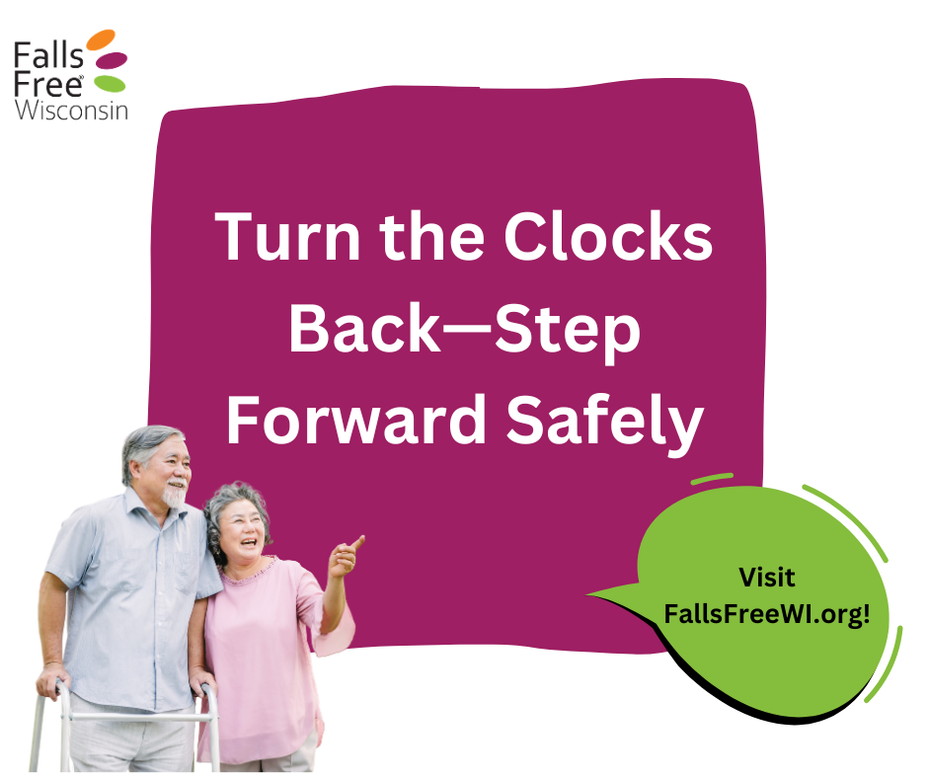 | As Daylight Saving Time ends, let’s use the extra hour as a reminder to take a few simple steps to improve our fall resiliency.  ▪️ Check that your home is well lit as the days get shorter.  ▪️ Wear supportive, non-slip shoes.  ▪️ Stay active with exercises that improve strength and balance.  ▪️ Schedule a vision check if it's been a while.  ▪️ Clear clutter from walkways and stairs to reduce trip hazards.  A few small changes today can help us stay steady, confident, and independent all season long.  Learn more at FallsFreeWI.org. #FallsFreeWI
11/5  *Bladder Health Awareness Month | 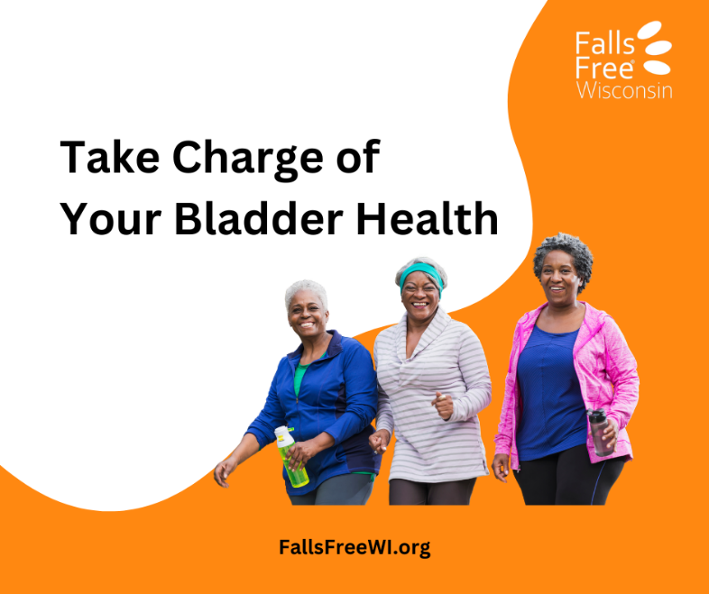 | Bladder health and falls are more connected than many people realize. Rushing to the bathroom, especially at night, can increase the risk of slipping or tripping.  Taking care of our bladder health can help us stay safe, confident, and independent.  Consider taking a Mind Over Matter: Healthy Bowels, Healthy Bladder workshop—proven to improve bladder symptoms in older women! Learn more and find a workshop near you at https://wihealthyaging.org/programs/live-well-programs/mom/ (also available in Hmong and Spanish).  Find more tips to reduce your risk of falls at FallsFreeWI.org #FallsFreeWI
*Social Connection Awareness Week  (Second full week in November)  Visit ConnectWI.org for additional promotional materials for this week | 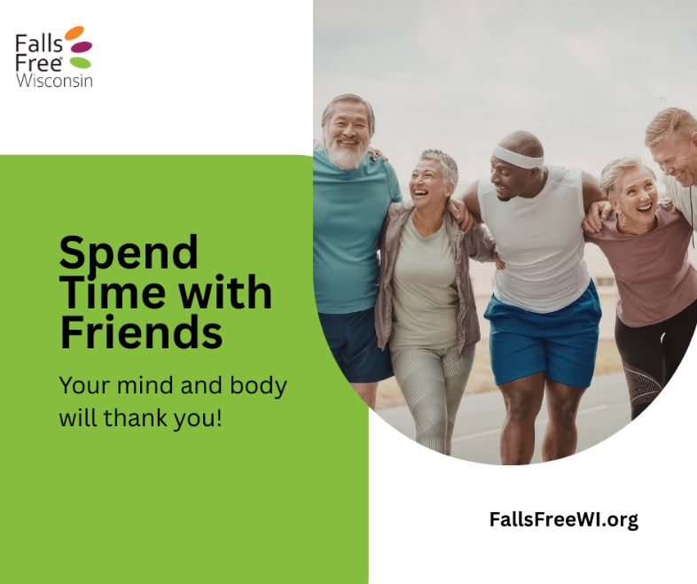 | Social connection plays an important role in healthy aging. Staying in touch with friends, family, and community helps us stay active, build confidence, and maintain routines that support balance and mobility.  From sharing a walk to checking in on each other, small moments of connection make a big difference. These everyday connections can help reduce loneliness and isolation and encourage habits that lower our risk of falls and increase our resilience.  Find tips to reduce our risk of falls at FallsFreeWI.org and meaningful ways to connect at ConnectWI.org. #FallsFreeWI
*Giving Tuesday  (Tuesday after Thanksgiving) | 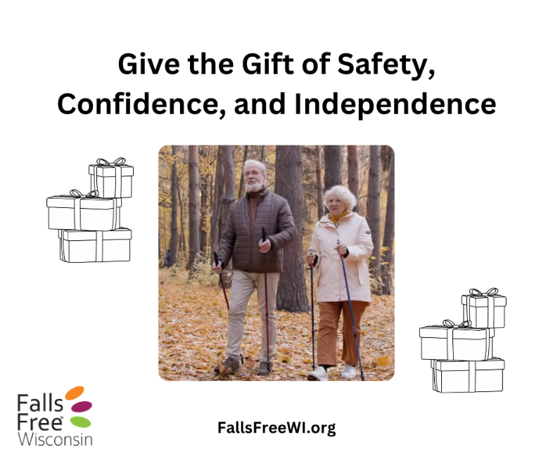 | This Giving Tuesday, give a gift that helps someone stay safe, active, and independent.  Consider practical gifts that support confidence and mobility, such as:  ▪️ Walking poles for outdoor adventures  ▪️ Grab bars or a shower chair for safer bathing  ▪️ Supportive, non-slip shoes  ▪️ Motion-sensor night lights to brighten walkways  ▪️ Membership to an exercise class or fall prevention workshop  ▪️ Your time to help make someone’s home safer or join them for a walk  Every gift, big or small, helps build a future where more people can age safely, confidently, and with the freedom to keep doing the things they love.  Learn more at FallsFreeWI.org #FallsFreeWI

