Date | Asset | Suggested Message for Social Media
10/1  *National Physical Therapy Month | 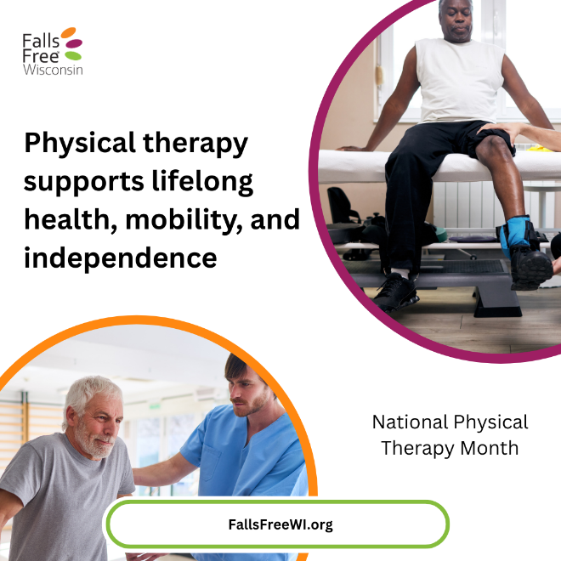 | October is National Physical Therapy Month!  Physical therapists play an important role in helping us stay active, mobile, and independent as we age. They can assess our balance, strength, flexibility, walking pattern, and fall risk, then develop a personalized plan to help us move with greater confidence.  Whether you're recovering from an injury or surgery, have noticed changes in your balance, or simply want to stay strong and resilient, it's never too early—or too late—to invest in your mobility.  This National Physical Therapy Month, ask your healthcare provider if a physical therapy referral would benefit you.  Learn more at FallsFreeWI.org #FallsFreeWI
*Active Aging Week  (Starts on the first Monday of the month) | 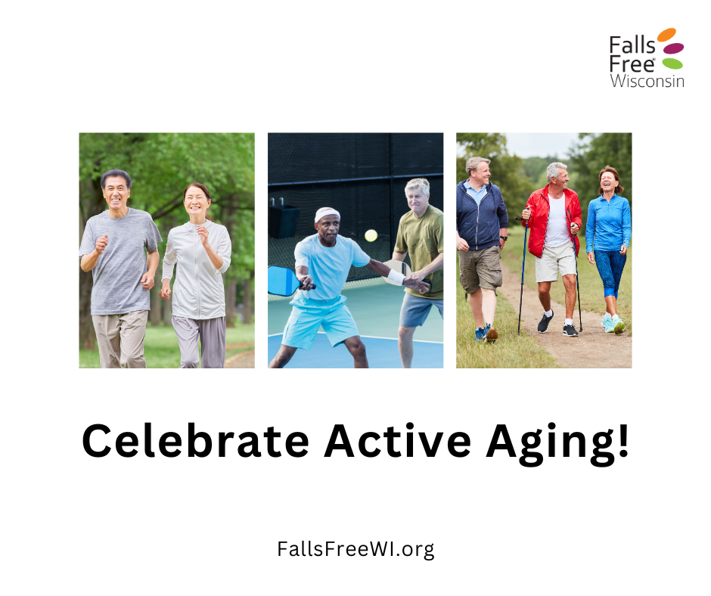 | Staying active is one of the best ways to reduce our risk of falls and maintain our independence as we age. Whether it's taking a walk with a friend, joining a fitness class, dancing, or participating in an evidence-based program like Stepping On, every step you take helps build strength, improve balance, and boost confidence.  This Active Aging Week, challenge yourself to get moving, stay connected, and try something new. Your future self will thank you!  Get started with our Strong Steps: Improve Balance and Strength to Prevent Falls guide. Find it at https://fallsfreewi.org/prevent-falls/balance-strength/ #FallsFreeWI
*Fire Prevention Week  (First full week in October) | 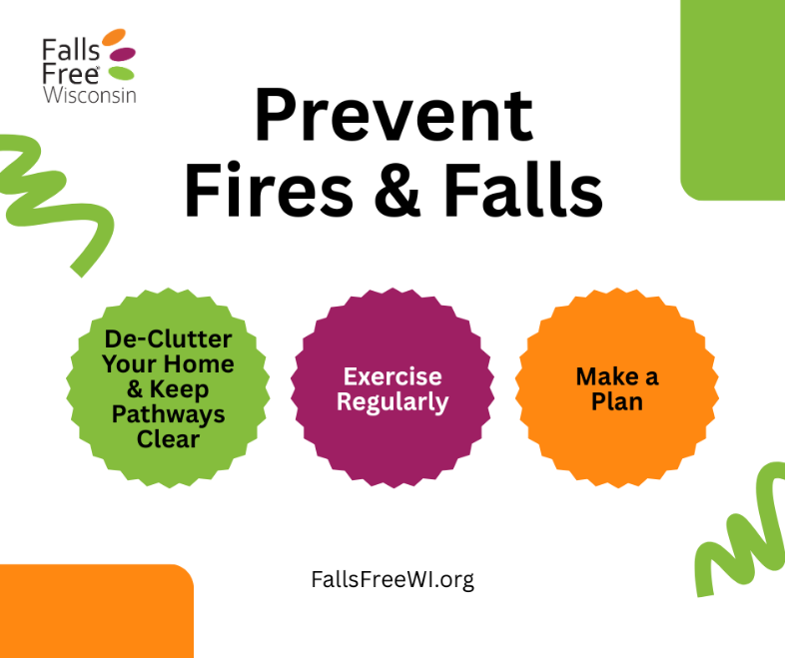 | 🔥Protect yourself from fires and falls this season!  A few simple steps can make our homes safer and help improve our resiliency:  ▪️ Clear clutter from walkways, stairs, and exits to reduce trip hazards and make it easier to leave quickly in an emergency  ▪️ Stay active with exercises that improve strength and balance  ▪️ Create and practice a home escape plan so everyone knows what to do if there's a fire  ▪️ Test smoke alarms regularly and replace batteries as needed  Small changes can make a big difference. Take time today to create a safer home and prevent fires and falls.  Learn more at FallsFreeWI.org. #FallsFreeWI
10/31  *Halloween | 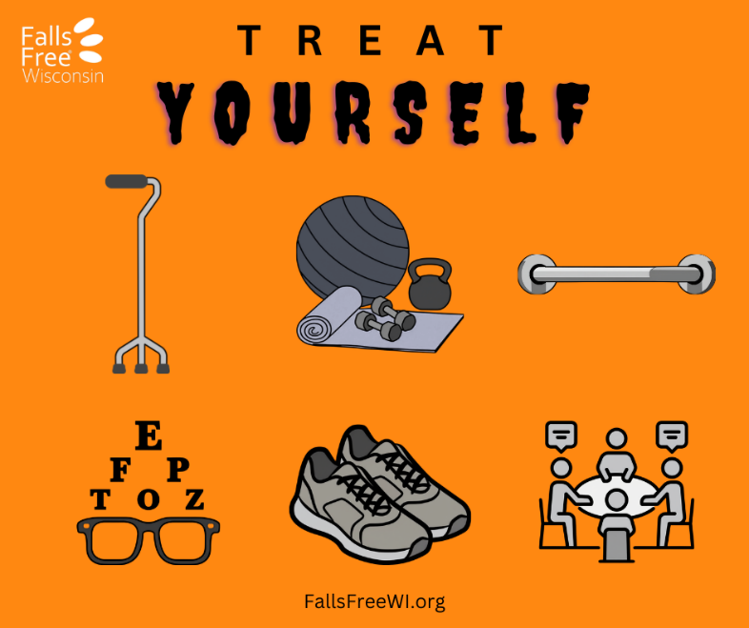 | Treat yourself to something better than candy this Halloween—safety, confidence, and independence!  There are plenty of ways to treat yourself this season:  ▪️ Use assistive devices like canes or grab bars to support yourself.  ▪️ Build strength, balance, and community through regular exercise.  ▪️ Schedule a vision check.  ▪️ Wear supportive, well-fitting shoes.  ▪️ Attend a fall prevention workshop, like Stepping On, to learn practical strategies for staying independent  The best Halloween treat is being able to do the things you love all year long.  Learn more at FallsFreeWI.org #FallsFreeWI

